CASE 1) MINIMIZING SURFACE AREA: FIXED VOLUME, LOWEST SURFACE AREA
Problem: Guy has 64 m³ of sand and wants to make a box to store it, using as little material as possible. Determine which box will have the least surface area?

In the problem above, Guy is dealing with a situation where volume is fixed and he needs to create a box with the lowest surface area so that he will spend the least amount of money in material.

The closer the box gets to being a _____________, the smaller the surface area is for a given volume.

How to solve the problem above algebraically

We know that cube will provide the lowest surface area for a fixed volume of 64 m³ of sand. You need a calculator that has cube root button.
Tech Tip for 2 possible buttons
$$\sqrt[x]{}$$
1) Type 3 for the root
2) Press $\sqrt[x]{}$
3) Type 64

$$\sqrt[3]{x}$$
1) Type 64
2) Press $\sqrt[3]{x}$
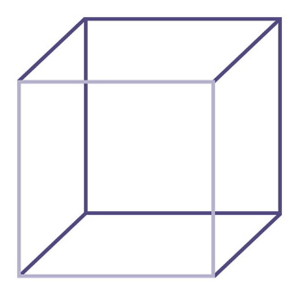

TRY: State the dimensions that will minimize (lowest) the surface area of a shadow box that has a volume of 35937 cm³.

CASE 2 – MAXIMIZING VOLUME: FIXED SURFACE AREA, MAXIMUM VOLUME
Dorsa has 24 m² of wood to make a toy box. Determine which box will have the maximum volume.

In the problem above, Dorsa has a fixed amount of material (surface area) and needs to create a box that will provide the largest volume to fit the most amount of toys.
The closer the box gets to being a _____________, the larger the volume is for a given surface area.

How to solve the problem above algebraically We know that cube will provide the largest volume.
Determine the dimensions of a box that maximizes the volume and has a surface area of 54 cm².

Questions
1. A magician has ordered a covered water tank for his next new act. He has enough money to pay for 150 m² of building material. What is the largest volume of water that can be held in his water tank?

2. State the dimensions that will minimize the surface area of a shadow box that has a volume of 19683 cm³.

3. You have been asked to make a single shelf cabinet, with a volume of 1.125 m³. However, it can only be 0.5 m deep.

a) Determine the dimensions that will minimize the surface area.
b) Assuming that the front face of the shelf is open, what total surface area of wood is needed?

