A A special case of quadratic-based geometry word problems involves having to **maximize** or **minimize** some dimension. This will involve finding the vertex of the quadratic equation you come up with, since the vertex will be the maximum or minimum of the graph.

**CASE 1: MAXIMIZING THE AREA**

**a) Four Sides**

**Ex1.** Farmer Pooley wants to buy some pigs. He needs to build a rectangular fenced area for the pigs and only has 40 m of fencing. He wants to build a rectangular pen that will give the pigs the maximum amount of space.

**a)** What dimensions should the pen be?

**b)** What is the maximum area?

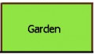

**Ex2.** Billy has 52 m of fencing. He wishes to maximize the area of a rectangular garden.

**a)** What are the dimensions of the rectangle he should use to maximize the area?

**b)** What is the maximum area?

**b) Three Sides**

**Ex1.** A farmer decides to enclose a rectangular garden, using the side of a rock wall as one side of the rectangle. What is the maximum area that the farmer can enclose with 100ft of fence?

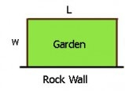

**Ex2.** A scout camp is being built on the shore of a lake. The scouts are digging a narrow, 60-m long drainage ditch to surround the rectangular camp on three sides, as shown. Determine the length and width of a ditch that will provide the **maximum** camp area. Use words and diagrams to show your reasoning.

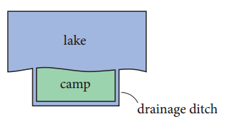

**CASE 2: PATH OF AN OBJECT**

The path of a ball is modelled by the equation $y=-x^{2}+2x+3$, where *x* is the horizontal distance, in metres, from a fence and *y* is the height, in metres, above the ground.

**a)** What is the maximum height of the ball, and at what horizontal distance does it occur?

**b)** Sketch a graph to represent the path of the ball.

**MAXIMIZING AREA**

1. Each rectangle has a perimeter of 24 units. Which one has the greatest area?

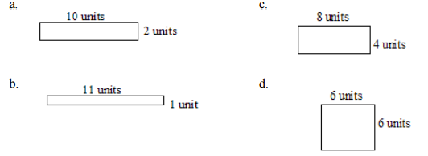

2. What is the maximum area of a rectangle with a perimeter of 60 km?

3. Sylvia is fencing a rectangular rose garden. The hardware store sells fencing for $22.50/m. Her family has $247.50 to spend. What dimensions should Sylvia use to build a garden with the greatest area?

4. Jordan is making a paddleball court. The court consists of a wall outlined by 40 m of paint. What dimensions will maximize the area of the paddleball court?

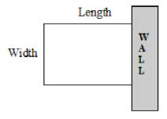

5. Raquel is making a quilt. She has 540 cm of fabric to border the quilt. What is the greatest possible area for the quilt?

6. Kelly is making an area to keep her dog outside. She has 25 m of fencing. The area will be against a garage as shown. What dimensions will maximize the area of the dog run?

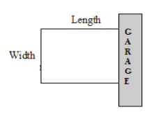

**PATH OF AN OBJECT**

1. Annie Pelletier won a bronze medal in the women’s springboard competition at the 1996 Summer Olympics in Atlanta. Pelletier somersaults from a 15-m high springboard. Her height *h* metres, above the water *t* seconds after she leaves the board is given by . Determine her maximum height. Include a labelled diagram of the parabola. (16 m)
2. A golfer attempts to hit a golf ball over a gorge from a platform above the ground. The equation that models the height of the ball is , where *h* is the height in metres at time *t* seconds after contact. What is the maximum height of the ball? Include a labelled diagram of the parabola. (180 m)
3. The height of a ball thrown vertically upward from a rooftop is modelled by , where *h* is the ball’s height above the ground, in metres, at time *t* seconds after the throw. Determine the maximum height of the ball. Include a labelled diagram of the parabola. (70 m)
4. The path of a volleyball hit from a height of 0.1 m above the ground can be approximated by the equation , where *x* is the horizontal distance travelled, in metres, and *h* is the height, in metres. Determine the maximum height of the ball and how far it travelled horizontally when it reached that maximum height. Include a labelled diagram of the parabola. (12.6 m, 2.5 m)
5. The path of a golf ball can be modelled by the equation , where *h* is the height of the golf ball, in metres, and *d* is the horizontal distance travelled, in metres. What is the maximum height of the golf ball and at what horizontal distance does the golf ball reach its maximum height? Include a labelled diagram of the parabola. (30 m, 100 m)
6. A Frisbee is passed to another team mate in a game of Ultimate Frisbee. The Frisbee follows the path , where *h* is the height, in metres, and *d* is the horizontal distance travelled, in metres. What is the maximum height of the Frisbee and at what horizontal distance does the Frisbee reach its maximum height? Include a labelled diagram of the parabola. (3 m, 10 m)
7. Mr. Mulock is throwing water balloons off the school rooftop. The path of each balloon is modelled by , where *h* is the balloon’s height above the ground, in metres, at time *t* seconds after the throw. Determine the maximum height of the balloon. Include a labelled diagram of the parabola. (39 m, 1 sec)
8. The path of a soccer ball kicked from the ground is given by , where *h* is the height, in metres, and *d* is the horizontal distance travelled, in metres. What is the maximum height of the ball and at what horizontal distance does the ball reach its maximum height? Include a labelled diagram of the parabola. (5 m, 10 m)
9. The equation  models the main rise and drop of a small rollercoaster, where *h* is the height above the ground, in metres, and *x* is the horizontal distance from a vertical support, in metres. Determine the maximum height of the roller coaster. Include a labelled diagram of the parabola. (10.125 m)
10. A BMX stunt ramp is being built for a movie. The cross section of the ramp is to be modelled by the equation , where *x* is the horizontal distance, in metres, from a camera location, and *y* is the vertical distance, in metres, from a horizontal filming platform. Determine the lowest point of the ramp (below the camera location). Include a labelled diagram of the parabola. (1.15 m below the camera)
11. What a waste of a great drink! For a science experiment, a Mentos candy was dropped into a bottle of Diet Coke. The initial fountain of the wonderful liquid flew through the air and landed straight in the sink as predicted. The predicted model of the fountain of liquid was , where *h* is the height of the liquid above the floor, in centimetres, and *x* is the horizontal distance from the bottle, in centimetres. Determine the maximum height of the liquid. Include a labelled diagram of the parabola. (330.75 cm)