**Investigation: Finding the Equation of a Line – given the slope and a point**

To write an equation y = mx + b form, you need two parts:

*m* = ________________ *b* = ________________

**Solving Graphically - If you have a graph, you can follow these steps to graph the relationship and then use your graph to find the equation. This is similar to graphing in y=mx+b form, but instead of plotting the intercept first, you plot the point given.**

1. **Plot the point given.**
2. **Use the slope to rise (up or down) and then run to the right to plot a second point**
3. **Extend the line to find the y-intercept**

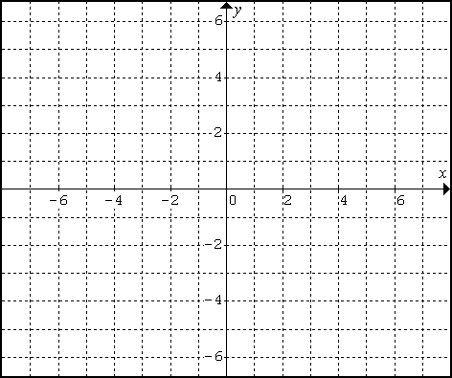A line has a slope of 2 (or ) and passes through the point (2,5) Find the equation of this line.



**Solving Algebraically - A graph may not always be given and the y-intercept may not always be an integer. You need to learn how to complete these types of problems algebraically for accuracy. We will use the same example as above to show that this method works the same as the visual, graphical model.**

A line has a slope of 2 (or ) and passes through the point (2, 5) Find the equation of this line.

Using the equation, , where m = slope and x and y represent the values of a point (x, y) substitute what you know and solve for b. *[or use the slope-point formula .]*

|  |  |
| --- | --- |
| Using y=mx+b | Slope-point Formula |

m = ______ (given) b = ______ Equation: _______________

**Practice: Finding the Equation of a Line – given the slope and a point**

Find the equation of each line without graphing.

|  |  |
| --- | --- |
| a) Slope is 5, passes through the point (1, 6) | b) Slope is -3, passes through the point (-1, -2) |
| c) Slope is , passes through the point (4, 4) | d) Slope is , passes through the point (10, 1) |
| e) Slope is 1.5, passes through the point (5, 8) | f) Determine the equation of the line perpendicular to y=2x-5 passing through the point (-3,4). |
| g) Determine the equation of the line parallel to  passing through the point | h) Margo’s pizza parlour charges $1.75 per topping. Sandra’s pizza had 6 toppings and cost $22.50. Find the equation that represents the cost of a pizza. |