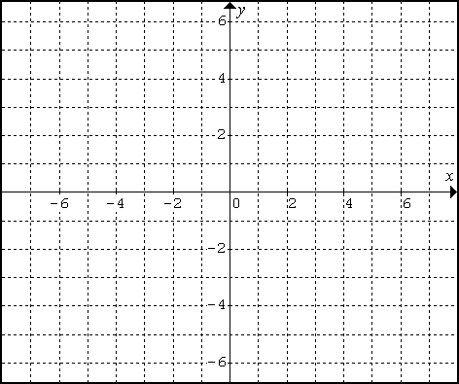**WARM UP**

A line has a slope of 2 (or ) and passes through the point (2,5) Find the equation of this line in y = mx + b form.



**DETERMINING THE EQUATION ALGEBRAICALLY**

As you saw above, to write an equation in y = mx + b (slope y-intercept) form, we need two parts:

* *m* = ________________
* *b* = ________________

**STEP 1: FINDING THE SLOPE (m)**

Questions come in different versions (cases). Sometimes they will provide you the slope and y-intercept, but most of the times you will have to figure out both. Finding the slope is the first step in determining the equations algebraically.

|  |  |  |
| --- | --- | --- |
| This one is rather easy because the slope is given to you.  **Ex:** **State** the slope of the line:  Determine the equation of a line that has a slope of 2/3 and passes through the point (2, 3). | We are given two points where we can calculate the slope using the formula.  **Ex:** **State** the slope of each line:  1) Determine the equation of a line that goes through points (1, 4) and (2, 8).  2) Find the equation of the line with an x-intercept of -5 and a y-intercept of 6.  3) with the same *x*-intercept as  3x -7y + 12 = 0 and through the point  (–6,–1).  4) with *x*-intercept –2 and intersecting the line x – 3y + 2 = 0 when x = -14 | We need to figure out the slope from another equation.  **Ex:** State the slope of each line:  1) A line parallel to line y = 2x + 3.  2) A line perpendicular to line  y = 2x + 3.  3) A horizontal line through (7, 8).  4) A line parallel to line y = -1 and through (12, 17). |

**STEP 2: FINDING THE Y-INTERCEPT (b)**

The second step is to figure out the y-intercept. You will use the coordinates (x and y) of a point on this line and plug into y = mx + b and solve for b.

**STEP 3: STATING THE EQUATION**

When you determine the slope (m) and the y intercept (b), using a therefore statement, you need to state the equation in

y = mx + b form. Simply, keep y and x, then replace m and b with their numerical values.

**Example:** Determine the equation of a line in y = mx + b form that has a slope of 2 and passes through the point (2, 5) algebraically.

**PRACTICE**

Determine the equation of each line without graphing.

|  |  |
| --- | --- |
| a) Slope is 5, passes through the point (1, 6) | b) Slope is -3, passes through the point (-1, -2) |
| c) Slope is , passes through the point (4, 4) | d) Slope is , passes through the point (10, 1) |

|  |  |
| --- | --- |
| e) Slope is 1.5, passes through the point (5, 8) | f) Determine the equation of the line perpendicular to  y = 2x-5 passing through the point (-3,4). |
| g) Determine the equation of the line parallel to  passing through the point | h) Margo’s pizza parlour charges $1.75 per topping. Sandra’s pizza had 6 toppings and cost $22.50. Find the equation that represents the cost of a pizza. |
| i) through (1, 1) and perpendicular to the line $y=-\frac{4}{3}x+9$ . | j) parallel to the line y = -x – 1 with an x-intercept of 4. |