|  |
| --- |
| **Germs! Germs! Germs!**  Certain bacteria, under the right conditions, multiply themselves.  You will use strips of paper, each representing a bacterium, to model its growth.  For this activity, each member of your group must choose a role:   * Recorder – records data * Counter – counts pieces for recorder * Reader – reads questions for other members in the group * Facilitator – keeps discussion of topic going |

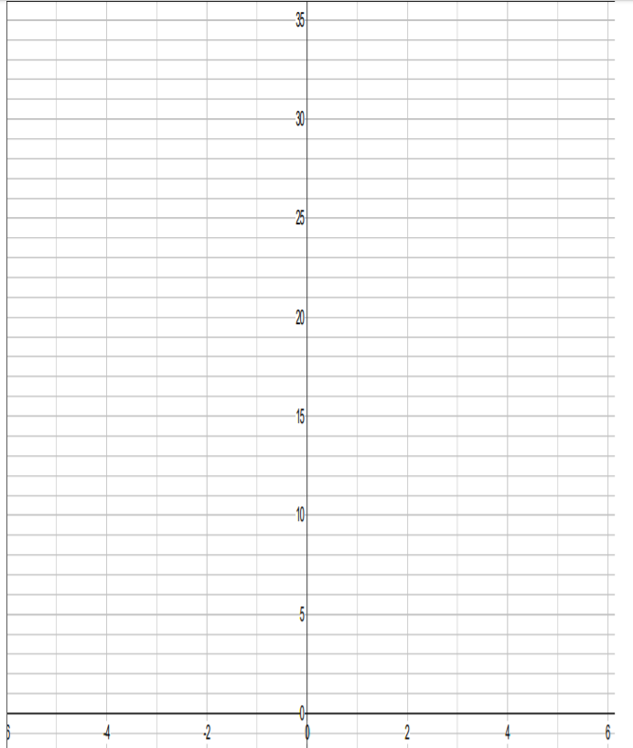Cut #1: Cut your paper into ____ equal pieces.

How many total pieces do you have? _____

Cut #2: Cut each piece into ____ equal pieces.

How many total pieces do you have? _____

Cut #3: Cut each piece into ____ equal pieces.

How many total pieces do you have? _____

Cut #4: Cut each piece into ____ equal pieces.

How many total pieces do you have? _____

Cut #5: Cut each piece into ____ equal pieces.

How many total pieces do you have? _____

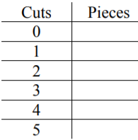

**Graph** your result on the grid provided.

**Identify** the characteristics of your graph.

* X – intercept
* Y - intercept

Create an equation to model the data in y = abx form.

y is total amount (leave y as is)

a is initial amount

b is growth factor (# of equal pieces each cut)

x is number of cuts (leave x as is)

**EXAMPLE 2:**

An antique costs $800. Its value increases at a rate of 50% each year. **Fill** out the chart below.

[***NOTE****: 50% is called the* ***growth rate*** *because the initial amount is increasing over time.*]



|  |  |  |  |
| --- | --- | --- | --- |
| **End of**  **Year** | **Increase in**  **Value** | **Total Value at the end of Year** | **Growth**  **Factor (b)** |
| 0 |  | = $800  *\* initial value (a)* |  |
| 1 | = 800 x 50%  = 800 x 0.50  = $400 | = 800 + 400  = $1200 | 1200 / 800  = 1.5 |
| 2 | = 1200 x 0.50  = |  |  |
| 3 |  |  |  |
| 4 |  |  |  |
| 5 |  |  |  |

**Graph** your result on the grid provided. Y scale (Total Value) 400 for one square; x scale (time) 1 year for two squares.

**Identify** the characteristics of your graph

x – Intercept:

y – Intercept:

**Equation**:

**EXAMPLE 3:** The population of Luckville is 50,000. Each year, the population decreases at a rate of 40%.

[***NOTE****: 40% is called the decay rate because initial amount is decreasing over time.*]



|  |  |  |  |
| --- | --- | --- | --- |
| **End of**  **Year** | **Decrease in**  **Population** | **Total Population at the end of Year** | **Decay**  **Factor (b)** |
| 0 |  | 50,000  *\* initial value* (a) |  |
| 1 | = 50,000 x 40%  = 50,000 x 0.40  = 20,000 | = 50,000 – 20,000  = 30,000 | 30,000/50,000  = 0.60 |
| 2 | = 30,000 x 0.40  = |  |  |
| 3 |  |  |  |
| 4 |  |  |  |
| 5 |  |  |  |

**Graph** your result on the grid provided. Y scale (Total Value) 2500 for one square; x scale (time) 1 year for two squares.

**Identify** the characteristics of your graph

x – Intercept:

y – Intercept:

**Equation**:

|  |  |  |
| --- | --- | --- |
| **Exponential models** represent quantities that change at a constant _________________; that is, the quantity is ____________ by a fixed amount at regular intervals.  **KEY WORDS**  Percent rate  Multiplied  Growth/decay  Exponential  y = abx  *a*  *b*  variable  growing  decaying   * In a table of values, the ________________ / ________________ factors are equal * The graph resembles an _______________________________ curve * The equation is written in the form _____________________ where ___ is the initial value and ___ is the growth/decay factor. Notice that the exponent is the _____________   ***Growth/Decay Factors***  In an exponential equation, , the growth/decay factor is given by the value of ***b***   |  |  | | --- | --- | | * If ***b*** > 1, the relation is ____________________ * y = *a* (1 + r) x * Growth rate = growth factor – 1 | * If 0 < ***b*** < 1, the relation is ___________________ * y = *a* (1 – r) x * Decay rate = 1 – decay factor | |

***EXAMPLE 1*** Determine the growth/decay factor or growth/decay rate in each of the following:

|  |  |  |
| --- | --- | --- |
| a)  **Growth factor (b) = 1.071**  **Growth rate**  **=** 1.071 – 1  = 0.071 * convert to percent  = 0.071 x 100  = 7.1% | b) | c) A = 2000(1.045) n |

***EXAMPLE 2*** Which models represent exponential relations? [*Hint: Calculate growth factor by dividing latter y value by the former one]*

* ***If growth /decay factor is constant, then it is exponential***

|  |  |  |  |  |  |  |  |  |  |  |  |  |  |  |  |  |  |  |  |  |  |  |  |
| --- | --- | --- | --- | --- | --- | --- | --- | --- | --- | --- | --- | --- | --- | --- | --- | --- | --- | --- | --- | --- | --- | --- | --- |
|  | |  |  | | --- | --- | | ***t*** | ***A*** | | 0 | 35 | | 1 | 25 | | 2 | 15 | | 3 | 5 | |  | |  |  | | --- | --- | | ***d*** | ***P*** | | 0 | 51.2 | | 1 | 64 | | 2 | 80 | | 3 | 100 | |
|  |  |  |  |
|  |  |  |  |