**TRIGONOMETRIC RATIOS**

When dealing with ________________________________________, we often use the Greek

letters ___to represent the measure of unknown _______________.

The __________________ is always the longest side, across from the right angle. The other two sides are named either ‘____________’ or ‘____________’ depending on the location of θ.

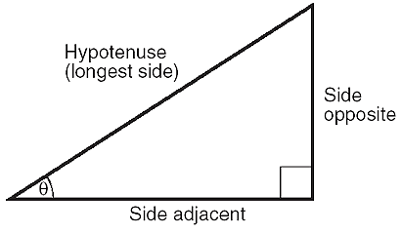 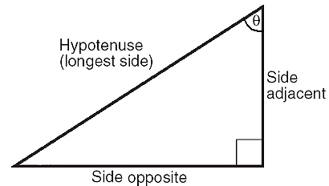

|  |  |  |  |  |  |  |  |
| --- | --- | --- | --- | --- | --- | --- | --- |
| **Ex1.** In, identify the hypotenuse, adjacent side, and opposite side for ________   |  |  | | --- | --- | | θ | Hypotenuse:  Adjacent:  Opposite: | | **Ex2.** In, identify the hypotenuse, adjacent side, and opposite side for ________   |  |  | | --- | --- | | θ | Hypotenuse: | | Adjacent: | | Opposite: | |
| **Ex3**. Label the hypotenuse (H), opposite (O) and adjacent (A) sides for marked angles.   |  |  |  | | --- | --- | --- | | θ | θ | | |  |  |  | |  |  |  | | |

|  |  |  |
| --- | --- | --- |
| **Formulas for Right Triangle Trigonometry** | | |
|  |  |  |
| where θ is the angle of reference | | |
| The formulas can be remembered by: **SOH CAH TOA** | | |

**CASE 1A: DETERMINE THE RATIO FROM THE TRIANGLE SIDES**

State the **three primary trig ratios** to four decimal places for the indicated angle:

|  |  |
| --- | --- |
| **http://lrd.kangan.edu.au/numbers/content/06_angles/images/angles_pg3_p7_pic1.jpgsin βo=**  **cos βo=**  **tan βo=**  β | **https://classconnection.s3.amazonaws.com/810/flashcards/851810/jpg/5_12_13_right_triangle1327512926059.jpgsin** θ**o=**  **cos** θ**o=**  θ  **tan** θ**o=** |

**CASE 1b: DETERMINE THE RATIO FROM THE ANGLE** (calculator must be in degree mode)

Determine the following ratios to four decimal places.

|  |  |
| --- | --- |
| sin 36o = | cos 55o = |
| tan 66o = | tan 6o = |

**CASE 2: DETERMINE THE ANGLE**

It is relatively straightforward to find the trig ratio knowing the angle, but what if we don’t know the angle? *We need the* ***inverse*** *(opposite) operation to find the angle.*

|  |
| --- |
| cos β = 0.8660 swap the ratio and the angle.  cos-1 0.8660 = β On the calculator press one of the following (depending on  your brand of calculator): either '2ndF cos' or 'shift cos'.calculator-sin-cos-tan |

|  |  |
| --- | --- |
| cos αo = 0.9952 | tan βo = 11.4301 |
| tan θo = 1.1918 | sin Ω0 = 0.1788 |
| sin αo = 0.9781 | Cos βo =0.019 |