**THE COSINE LAW**

We can use the cosine law when we know:

**KEY WORDS**

Length

Two sides

Opposite angle

**SIDE - SIDE - SIDE (SSS) SIDE - ANGLE - SIDE (SAS)**

A

B

C

4

5

6

X

Y

Z

3

45o

5

***THE COSINE LAW: SOLVING FOR SIDES***

If you need to find the __________ of a side, you need to know the other ________ ______ and the ________ ______.

You need to use the version of the Cosine Rule where a2 is the subject of the formula:

***a*2 = *b*2 + *c*2 – 2*bc* cos(*A*)**

Side a is the one you are trying to find. Sides b and c are the other sides, and angle A is the angle opposite to side a.

**Solved Example:** Determine the length of x.

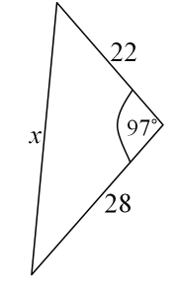

|  |  |  |
| --- | --- | --- |
| Step 1 | Start by writing out the Cosine Rule formula for finding sides:   |  | | --- | | *a*2 = *b*2 + *c*2 – 2*bc* cos(*A*) | |
| Step 2 | Fill in the values you know, and the unknown length:   |  | | --- | | *x*2 = 222 + 282 – 2×22×28×cos(97°) |   It doesn't matter which way around you put sides *b* and *c* – it will work both ways. |
| Step 3 | Evaluate the right-hand-side and then square-root to find the length:   |  |  |  |  | | --- | --- | --- | --- | | *x*2 | = | 222 + 282 – 2×22×28×cos(97°) | *(evaluate the right hand side)* | | *x*2 | = | 1418.143..... | *(square-root both sides)* | | *x* | = | 37.7 (accurate to 3 significant figures) | | |

***THE COSINE LAW: SOLVING FOR AN ANGLE***

If you need to find the size of an angle, you need to use the version of the Cosine Rule where the cos(A) is on the left:



It is very important to get the terms on the top in the correct order; b and c are either side of angle A which you are trying to find and these can be either way around, but side a must be the side opposite angle A.

**Solved example:** Determine the angle of P to the nearest degree.

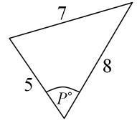

|  |  |  |  |  |  |
| --- | --- | --- | --- | --- | --- |
| Step 1 | Start by writing out the Cosine Rule formula for finding angles:   |  |  |  | | --- | --- | --- | | cos(*A*) | = | *b*2 + *c*2 – *a*2 | | 2*bc* | |
| Step 2 | Fill in the values you know, and the unknown length:   |  |  |  | | --- | --- | --- | | cos(*P*°) | = | 52 + 82 – 72 | | 2 × 5 × 8 |   Remember to make sure that the terms on top of the fraction are in the correct order. |
| Step 3 | Evaluate the right-hand-side and then use inverse-cosine (cos–1) to find the angle:   |  |  |  |  | | --- | --- | --- | --- | | cos(*P*°) | = | 52 + 82 – 72 | *(evaluate the right-hand side)* | | 2 × 5 × 8 | | cos(*P*°) | = | 0.5 | *(do the inverse-cosine of both sides)* | | *P*° | = | cos–1(0.5) = 60° | | |

The **COSINE LAW** can be used to solve triangles when given information includes:

* SIDE – SIDE – SIDE
* TWO SIDE MEASURES AND AN ANGLE IN BETWEEN THOSE SIDES.

***EXAMPLES***:

1. Find the measure of the unknown side to the nearest tenth

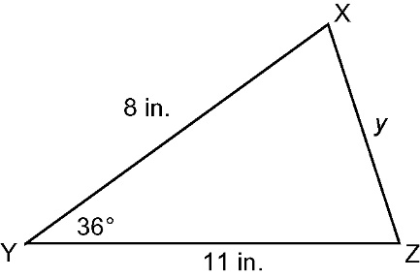

1. Find the measure of the marked angle to the nearest degree

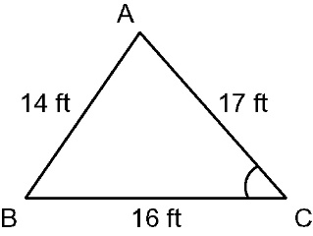

1. Solve *ABC* given cm, cm, and cm

**Cosine Law Practice**

1. Find the measure of the unknown side to the nearest tenth.

|  |  |
| --- | --- |
| 1. taBLM1-10-1s4-5 | 1. taBLM1-10-1s4-4 |
| 1. In *ABC* given that , m, and m, find *a* | 1. In *ABC* given that , mm, and mm, find *b* |

1. Find the measure of the marked angle to the nearest degree.

|  |  |
| --- | --- |
| 1. taBLM1-10-1s4-2 | 1. taBLM1-10-1s4-3 |
| 1. In *ABC* given that cm, cm, and cm, find | 1. In *ABC* given that ft, ft, and ft, find |

1. Solve *ABC* given , cm, cm
2. Solve *ABC* given cm, cm, cm
3. Mark says he can solve the following triangle using the sine law. Cassandra says she can solve the triangle using the cosine law. Who is correct? Explain.

