$$y=a\left[b^{k(x-d)}\right]+c$$
1. Sketch the graph of $f\left(x\right)=2^{x},$ then sketch$g\left(x\right)=2^{x}+4$, and$h\left(x\right)=2^{x}-3$ by applying the transformations.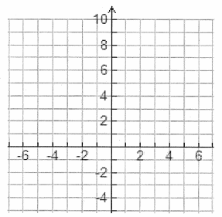
 | Domain | Range | y-intercept | Asymptote
$$f\left(x\right)= 2^{x}$$
$$g\left(x\right)= 2^{x}+4$$
$$h\left(x\right)= 2^{x}-3$$

2. Sketch the graph of$f\left(x\right)=2^{x}$, g$\left(x\right)=2^{x-2}$ and $h\left(x\right)=2^{x+3}.$
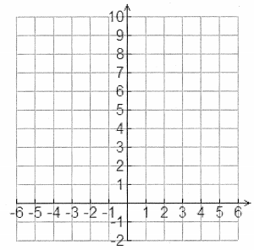
 | Domain | Range | y-intercept | Asymptote
$$f\left(x\right)= 2^{x}$$
$$g\left(x\right)=2^{x-2}$$
$$h\left(x\right)=2^{x+3}.$$
3. Sketch the graph of $f\left(x\right)=2^{x}, g\left(x\right)=3\left(2^{x}\right), and h\left(x\right)=\frac{1}{2}\left(2^{x}\right).$
 | Domain | Range | y-intercept | Asymptote
$$f\left(x\right)= 2^{x}$$
$$g\left(x\right)=3\left(2^{x}\right)$$
$$h\left(x\right)=\frac{1}{2}\left(2^{x}\right)$$

4. Sketch the graph of $f\left(x\right)=2^{x}, g\left(x\right)= 2^{2x}, and h\left(x\right)=2^{\frac{1}{2}x}.$
 | Domain | Range | y-intercept | Asymptote
$$f\left(x\right)= 2^{x}$$
$$g\left(x\right)= 2^{2x}$$
$$h\left(x\right)=2^{\frac{1}{2}x}$$
Use the graph of $f\left(x\right)= 3^{x} to sketch the graph of g\left(x\right)=3^{2x}.$
5. a. Use the graph of $f\left(x\right)=2^{x} to sketch the graph of g\left(x\right)=2^{-x} and h\left(x\right)=-2^{x}$
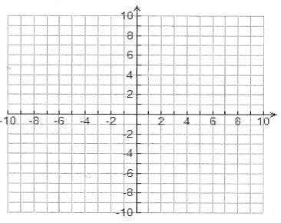
 | Domain | Range | y-intercept | Asymptote
$$f\left(x\right)= 2^{x}$$
$$g\left(x\right)= 2^{-x}$$
$$h\left(x\right)=-2^{x}$$
$$f\left(x\right)= b^{-x}$$
$$f\left(x\right)= {-b}^{x}$$

6. State the MAPPING NOTATION, and then describe the transformations:
a. $f\left(x\right)=3\left(2^{-x+2}\right)-1$

b. $f\left(x\right)=-4^{-2x+2}+7$

General form of transformed exponential function:
$$y=a\left[b^{k(x-d)}\right]+c$$
Effect of :
a: when i) $a>1$, it is a vertical stretch by a factor of $|a|$ ex: y = 2[3^{x}]
ii) $0<a<1$, it is a vertical compression by a factor of $|a|$ ex: y = 0.5[3^{x}]
y coordinate
iii) $a<0$, it is a vertical reflection ex: y = -2[3^{x}]

c: when $c>0$, vertical shift “c” units up ex: y = 2[3^{x}] + 1
$c<0$, vertical shift “c” units down ex: y = 2[3^{x}] - 1

k: when $k>1$, it is a horizontal compression by a factor of $|\frac{1}{k}|$ ex: y = 3^{2x}
x coordinate
$0<k<1$, it is a horizontal stretch by a factor of $|\frac{1}{k}|$ ex: y = 3^{1/2x}

d: when $d>0$, horizontal shift “d” units right ex: y = 3^{2(x - 2)}
REMEMBER TO FACTOR
$d<0$, horizontal shift “d” units left ex: y = 3^{2(x + 2)}

b: when $b>0$, it is an exponential GROWTH ex: y = 2[3^{x}]
$b<0$, it is an exponential DECAY ex: y = (1/3)^{x}

