x-Intercepts of a Quadratic Relation

The __________________ of a quadratic equation are also called the __________ of the parabola

|  |  |
| --- | --- |
| **To graph a parabola in VERTEX form, , the following is needed:** | |
| coordinates of the vertex |  |
| equation of the axis of symmetry |  |
| *y –* intercept |  |
| *y –* intercept reflection point |  |
| Direction of opening |  |
| Vertically stretched |  |
| Vertically compressed |  |

|  |  |
| --- | --- |
| **To graph a parabola in STANDARD form, , the following is needed:** | |
| coordinates of the roots  (given by the factors) |  |
| axis of symmetry  (x value of vertex) |  |
| the optimal value  (y value of vertex) |  |
| y-intercept |  |
| *y –* intercept reflection point |  |
| direction of the opening and any vertical stretch or compression |  |
| Vertex |  |

***EXAMPLE 1***

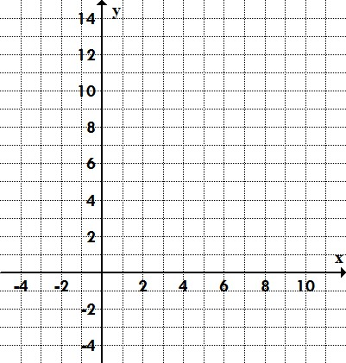Graph the parabola defined by 

**Step 1**: **Factor** the trinomial to find and plot the   
**roots** (x-intercepts) of the parabola.

**Step 2**: Find the **axis of symmetry** (the midpoint between the x-intercepts)

**Step 3**: **Plot** the **y-intercept** 🡪 given by ‘**c**’ in 

**Step 4**: **Plot** the **y-intercept reflection point** (mirror over axis of symmetry)

**Step 5**: Determine the **optimal value**

**Step 6**: **Plot** the **vertex** 🡪 (x, y) = (axis of symmetry, optimal value)

**Step 7**: **Draw a smooth curve** between all points (use step pattern if necessary)

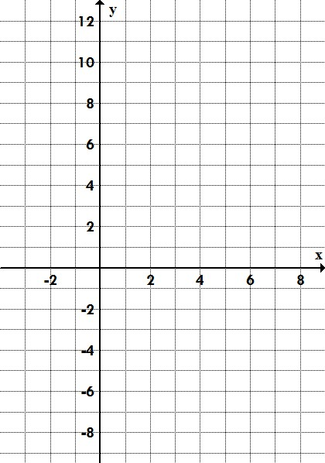***EXAMPLE 2***

Graph the parabola defined by 

**Step 1**: **Factor** the trinomial to find and plot the   
**roots** (x-intercepts) of the parabola.

**Step 2**: Find the **axis of symmetry** (the midpoint   
between the x-intercepts)

**Step 3**: **Plot** the **y-intercept** 🡪 given by ‘**c**’ in 

**Step 4**: **Plot** the **y-intercept reflection point** (mirror over axis of symmetry)

**Step 5**: Determine the **optimal value**

**Step 6**: Determine the **vertex** 🡪 (x, y) = (axis of symmetry, optimal value)

**Step 7**: **Draw a smooth curve** between all points (use step pattern if necessary)

x-Intercepts of a Quadratic Relation – Practice

**1.** Identify the *x*-intercepts of each quadratic relation.

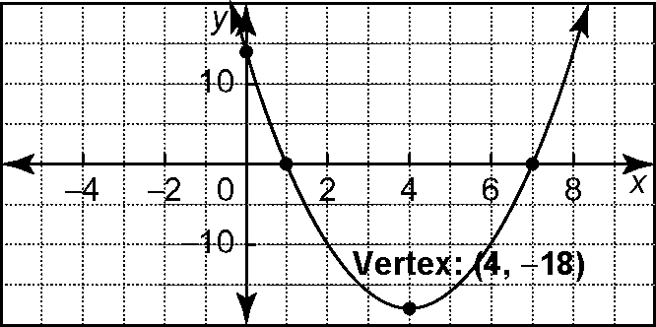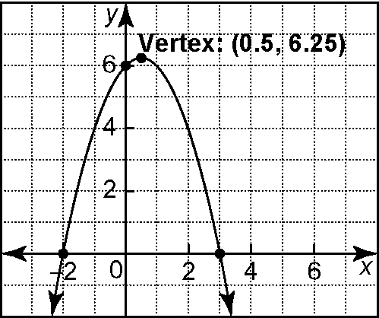**a) b)**

**2.** Identify the zeros of each quadratic relation.

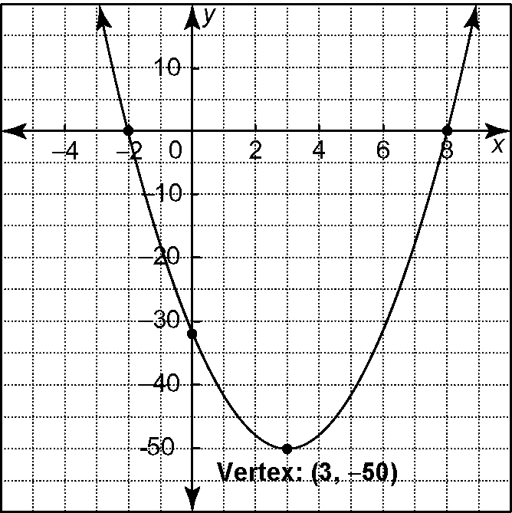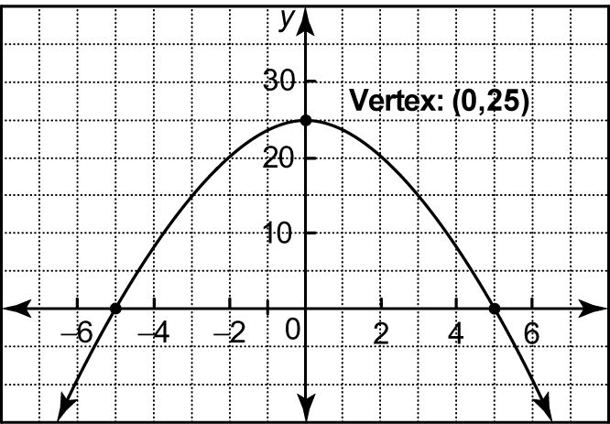**a) b)**

**3.** Identify the zeros of each quadratic relation.

**a)** *y* = (*x* − 1)(*x* + 2) **b)** *y* = 3(*x* + 7)(*x* − 5)

**c)** *y* = −2*x*(*x* − 6) **d)** *y* = −(*x* + 6)(*x* − 9)

**e)** *y* = 4(*x* + 8)(*x* − 2) **f)** *y* = 6(*x* − 6)(*x* + 6)

**4.** Find the zeros by factoring. Graph 3 of the equations.

**a)** *y* = *x*2 + 8*x* + 15 **b)** *y* = *x*2 − 2*x* − 8

**c)** *y* = 2*x*2 − 18 **d)** *y* = 3*x*2 − 12*x* − 36

**e)** *y* = −*x*2 + 4*x* + 5 **f)** *y* = 6*x*2 − 24

**5.** Given each relation in vertex form, express the relation in standard form and in intercept form.

**a)** *y* = (*x* + 3)2 − 1 **b)** *y* = −2(*x* + 1)2 + 32 **c)** *y* = 4(*x* − 3)2 − 100

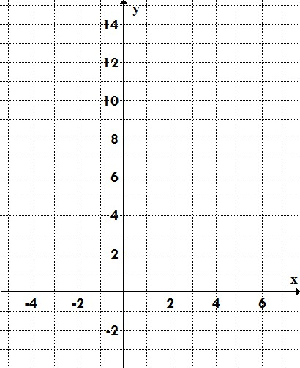**6.** A rock was thrown from a cliff. Its path can be modelled by the relation *h* = −0.5*d* 2 + *d* + 12, where *h* is the height of the rock above the ground and *d* is the horizontal distance, both in metres.

**a)** How high is the cliff?

**b)** Write the relation in intercept form.   
What are the zeros of the relation?

**c)** At what horizontal distance did the rock   
hit the ground?

**d)** Graph the relation.

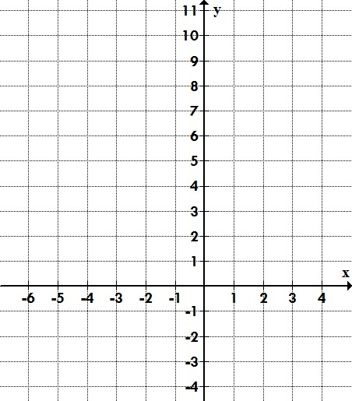**7.** Graph the parabola defined by y = x2 + 6x + 9

Find the:

1. roots of the parabola
2. axis of symmetry
3. y-intercept
4. y-intercept reflection point
5. optimal value
6. vertex