Chapter 4 Task Rubric
Category | Level 1  (50–59%) | Level 2  (60–69%) |  |  | Level 3  (70–79%) |  |  | Level 4  (80–100%)

Knowledge and Understanding
 | With limited accuracy | With some accuracy |  |  | With considerable accuracy |  |  | With a high degree of accuracy
• calculates total area
• estimates the price based on the type of the house and location
• uses online calculator to determine mortgage payments
• determines the details of the house
• determines monthly expenses

Thinking
 | With limited effectiveness | With some effectiveness |  |  | With considerable effectiveness |  |  | With a high degree of effectiveness
• judges the reasonableness of calculations
• designs a mortgage plan

Communication
• uses conventions
• uses vocabulary and terminology

Application
• transfers knowledge and skills to new contexts
• makes connections between various concepts

MY DREAM HOME
In this project, you will design your dream house and get a mortgage to purchase it. You have two options to create your floor plan: using an online tool or the traditional way –paper and pencil.

WHAT YOU CAN CREATE WITH THE ONLINE TOOL:
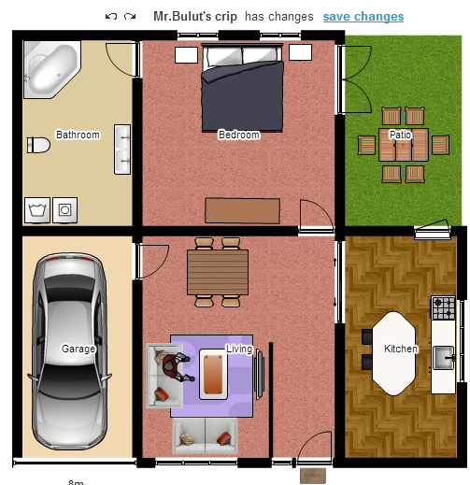
LOCATION: Aurora TYPE: Bungalow PRICE: $450,000 DETAILS: 1BR, garage, patio, A/C

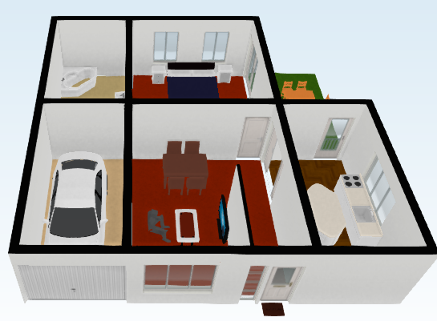
IMPORTANT: To calculate the size (area) of your house, double click on the floor plan. For example, Mr. Bulut’s bathroom is 12m². When you find the area for each section, you can calculate the total size of your place.
AREA = LENGTH X WIDTH (This is what the computer does to calculate the area of the bathroom.)
VERY IMPORTANT: When you create your floor plan, dimension estimates have to be rather close to actual measurements.

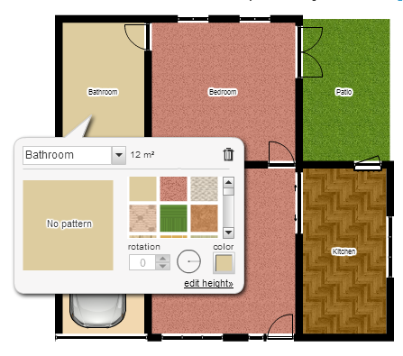
DIMENSIONS
Bathroom: 12m² (3m x 4m)
Bedroom: 21m²
Patio: 14.1m²
Kitchen: 14.6m²
Living Room: 25.2m²
Garage: 14.4m²
Total: 101.3 m² or 1090.38ft²

OPTION 1: GRID PAPER (Scale 1 SQUARE is 0.5m)

OPTION 2: Follow the instructions below:
STEP 1) SETTING UP A FREE ACCOUNT
Go to www.floorplanner.com and sign up for free.

STEP 2) CREATING A NEW PROJECT
Click on , choose 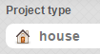 , name your project MY DREAM HOME, enter your location (e.g. Aurora, Newmarket, Toronto, etc.). (NOTE: To keep it simple, leave the floor number as 1.) Then, click on Create Project.

STEP 3) HOW DOES THE SITE WORK?
Watch the first tutorial. http://tinyurl.com/qacwt9o

STEP 4) WHEN COMPLETE
Either email your floor plan 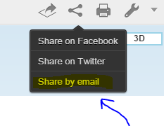to bulut.sicramaz@yrdsb.ca OR print and attach here.

2) DIMENSIONS (m² or squared feet)
Master Bedroom
Bedroom 2
Bedroom 3
Living Room
Kitchen
Laundry Room
Bathroom
Garage
Other
Total
1) DETAILS
LOCATION
TYPE OF HOUSE
PURCHASE PRICE (considering the location of your house, research similar places for an estimate price.)
# of Bedrooms
# of Bathrooms
Total Parking Space
Heating Type
Other

3) MORTGAGE DETAILS
A) CALCULATING YOUR DOWN PAYMENT:
You have saved 10% of the price of your dream house as a down payment.
ANSWER: How much is your down payment? __________________
B) CALCULATING YOUR MORTGAGE: Your mortgage amount that you will borrow from a bank is the difference between price and your down payment.
ANSWER: How much money will you borrow as a mortgage? I will borrow $___________.
Now you need to do some research to find out the best mortgage rate. (Hint: Google online mortgage calculator.)

NAME OF THE BANK |  | AMORTIZATION:  (How long will it take?)
MORTGAGE AMOUNT: |  | PAYMENT FREQUENCY:
TERM AND TYPE: |  | MONTHLY PAYMENTS:
INTEREST RATE: |  | legal fees, land transfer taxes and other costs  (4% of the purchase price)

LET’S PUT IT ALL TOGETHER.
1) How much was the original price of your dream house? $_______________
2) What did you calculate for your monthly payments? (E.g. $2000) $____________
3) How many payments will you make until you pay off your mortgage? (E.g. 25 years x 12 = 300 payments)

4) How much will you pay the bank in total? (E.g. $2000 x 300 = $600,000)

5) Why do you think you pay more than the actual cost of the house?

6) Did the amount of interest you paid surprise you? If yes, why?

7) What is the most important knowledge that you gained from this project?

8) List all of the expenses with estimate prices you can think of for the house you designed (E.g. hydro $50/month, gas $70/month, etc.)
HOME EXPENSES | MONTHLY COST

