**Solving Graphically - If you have a graph, you can follow these steps to graph the relationship and then use your graph to find the equation. This is similar to graphing in y=mx+b form, but instead of plotting the intercept first, you plot the point given.**

1. **Plot the two points**
2. **Draw the line, by connecting the points, and extending in both directions**
3. **Calculate the slope, and identify the y-intercept**

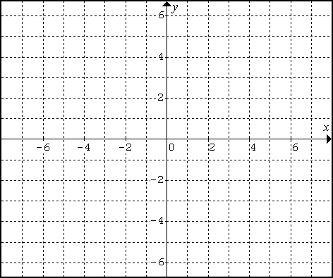

A line passes through the points (3,6) and (-4,-1). Plot the points, and draw the line, then find the equation of the line.



**Solving Algebraically - A graph may not always be given and the y=intercept may not always be an integer. You need to learn how to complete these types of problems algebraically for accuracy. We will use the same example as above to show that this method works the same as the visual, graphical model.**

A line passes through the points (3,6) and (-4,-1). Find the equation of the line.

First, you must calculate the slope .

Then, using the equation, , where m = slope and x and y represent the values of a point (x, y) substitute what you know and solve for b. *[or use the slope-point formula .]*

|  |  |
| --- | --- |
| Using y=mx+b | Slope-point Formula |

m = ______ b = ______ Equation: _______________

**Practice: Finding the Equation of a Line – given two points**

Find the equation of each line without graphing.

|  |  |
| --- | --- |
| a) Passes through the points (-6, 2) and (-3,1). | b) Passes through the points (6,3) and (-6,0). |
| c) Passes through the points (3, 6) and (-4,-1). | d) Passes through the points (2, -4) and (-1, 5). |
| e) Passes through the points (-3, 5) and (7, -4) | f) Passes through the points (-5, -1) and (5, -1) |
| g) Find the equation of the line with an x-intercept of -5 and a y-intercept of 6. | h) The temperature of a pool decreased at a constant rate once the sun went down. Marcus checked the temperature twice. After 1 hour, the temperature was 72○F. After 4 hours, the temperature was 60○F. Find the equation of this relationship. |
| Answers: a) y = -1/3x, b) y = 1/4x +1.5, c) y = x + 3, d) y = -3x + 2, e) y = -9/10x + 2.3, g) y=1.2x + 6 f) y = -1, h) y=-4x+76 (the starting temp. was 75○F and the temperature decreases 3○F per hour. | |