Communication in all questions must include:
- Enough steps shown to clearly demonstrate thinking  - Solutions that are neat and easy to follow  - Proper use of mathematical symbols  - Equal signs aligned | - Units used as required  - Concluding statements for all word problems  - Fractions reduced to lowest terms  - Correct rounding.

2D Geometry
1. Find the area and perimeter of each shape:
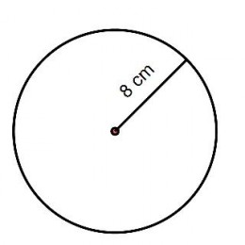

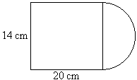

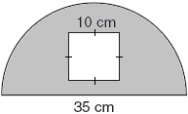

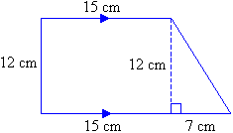

3D Geometry: Find the surface area and volume of each figure:
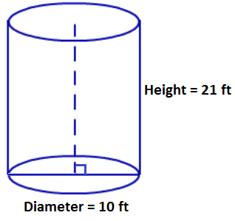
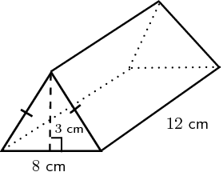

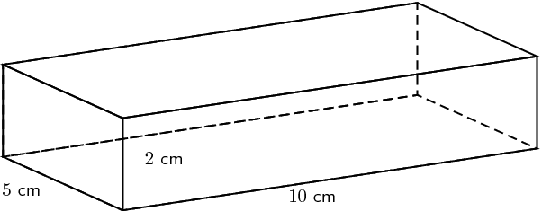

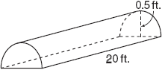

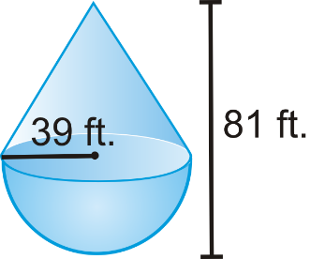
*Slant = 57 ft. long

- The three rectangles shown all have the same perimeter. Which has the largest area? Explain in words how you made your choice.

- A rectangular room needs to have an area of 60 m². What are the dimensions of the room with a minimum perimeter, and what is the perimeter?

- You need to build a rectangular enclosure in your backyard. You buy some prebuilt sections of fencing which are each 0.25m long. You buy a total of 40m of fencing. Determine the dimensions (length and width) which will maximize the area of your enclosure

- 36 m of rope are available to create a rectangular swimming area, using the beach as one side. What is the maximum area that can be produced?

- A marine biologist is collecting data. She has 100 m of rope with buoys to outline a rectangular or circular research area on the surface of the water. Which figure will enclose a greater area? Justify your answer by showing all calculations.

- A rectangular-based prism must have a surface area of 96 cm². What are the dimensions of the prism that produce the maximum volume, and what is the volume?

- A rectangular-based prism has a volume of 50 in³. Determine the minimum surface area.

