**Solving Problems Using Trigonometry**

|  |
| --- |
| **Steps to solving trigonometry word problems:**   1. Read the problem carefully and underline the key words 2. Determine what is given in the problem, and what you need to find out. 3. Use information given to find the unknown. 4. Sometimes you have to calculate value of something else first (an intermediate step) before you can calculate the value you are asked to find. |

**Before and during your problem-solving process, consider these questions:**

1. Can I find angles using the sum of angles in a triangle (180o)?
2. Do I need to make any measurement conversions?
3. Can I use Pythagorean Theorem?
4. Can I use Trigonometry Ratios (SOH-CAH-TOA)?
5. Can I use Sine Law?
6. Can I use Cosine Law?

The flowchart below shows how to decide which method to use:

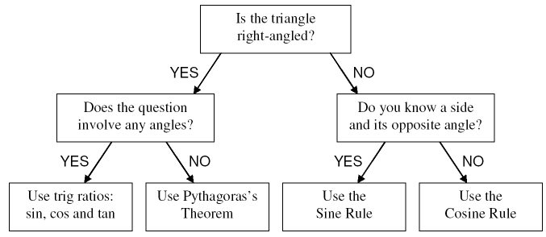

**TRIGONOMETRY APPLICATION PROBLEMS**

|  |
| --- |
| Read each question carefully, underline key information, draw a picture if none is given and decide which trigonometry method you will use to solve the problem. Round angles to the nearest degree and lengths to the nearest tenth, unless otherwise stated. |

1. A flagpole casts a shadow 17.7 m long when the angle of elevation of the sun is 66.4. How tall is the flagpole?
2. The Bermuda Triangle is an area off the coast of Miami, extending to the islands of Bermuda and Puerto Rico. The distance from Miami to Bermuda is 1680 km, from Bermuda to Puerto Rico is 1094 mi, and from Puerto Rico to Miami is 1600 km. Find the measures of the angles of this triangle. Hint: 1 mile is approximately 1.6 kilometres.

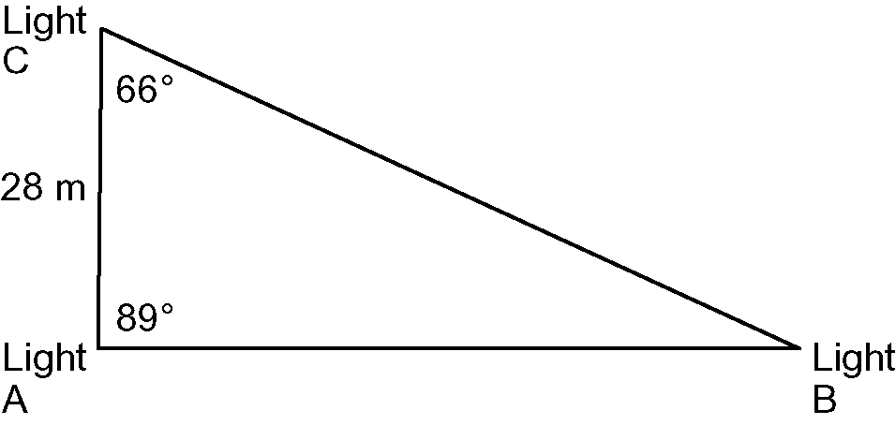

1. To create a dramatic lighting effect during a school play, the lighting crew has installed three lights in the arrangement shown. How far apart are the Lights A and B?
2. A ferry is used to transport guests from the dock to two hotels across a large lake. The hotels are located 550 m apart. The first hotel is at a 49 angle between the dock and the second hotel. The second hotel is at a 56 angle between the dock and the first hotel. How far is each hotel from the dock?



**54o**

**38o**

**325 m**

1. Hassim and Seema are standing 325 m apart, watching a   
   hot air balloon above them. Hassim measures the angle of elevation to the balloon to be 54. Seema measures the angle of elevation to the balloon to be 38.
2. How far is each person from the balloon, to the nearest metre?
3. What is the height of the balloon, to the nearest metre?
4. From one end of a bridge above a railroad track, the angle of depression to the tracks is 37. If that point is 112 m from the track and the bridge is 122 m long, how far from the other end of the bridge is the track, to the nearest metre?
5. A funnel used to pour oil into an engine is in the shape of a cone. The sides of the cone are 15 cm long and the angle between the sides is 17.9. What is the diameter of the cone?
6. Michael stands 10 m from the base of a building. He measures the angle of elevation to the top of the building to be 65. Michael’s measurement was made from 6 ft above the ground. Determine the height of the building to the nearest metre. Hint: 1 m  3.28 ft

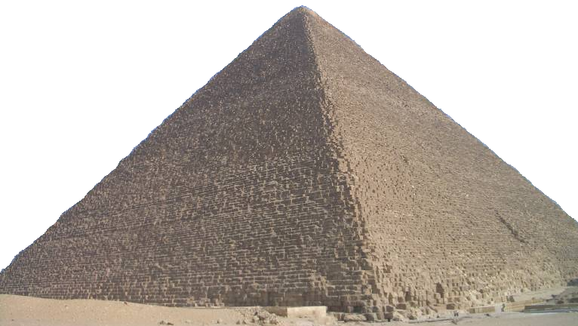

1. The ancient Greek mathematician Talis used trigonometry to find the slant side length of the face of the Great Pyramid of Giza. An archeologist wants to replicate Talis's calculations. She measures the base length along one side of the pyramid to be 230 m and the angle of elevation of the side to be 52. Calculate the slant side length.
2. Will a golfer using a wedge that sends the ball into the air at an angle of 64, be able to hit her ball over a 30 ft tree if he is 7 yd in front of the tree? Hint: 1 yd = 3 ft.
3. Two ski poles are resting against each other. The tips of ski poles are stuck into the ground   
   17 cm apart and the handles meet 110 cm above the ground. What angle do the ski poles   
   form where they touch?

Ourtown

Mytown

Hometown

4.5 km

3.9 km

62o

1. Three roads join Hometown, Mytown, and Ourtown.
2. What is the distance from Hometown to Ourtown?
3. What angles do the roads make at Hometown and at Ourtown?
4. Two cyclists leave from the same location with an angle of 63 between their paths. John cycles at a speed of 35 km/h and Marcos at a speed of 40 km/h. How far apart are the after 3 hours?
5. The pitch of a roof is 45. The rise of the roof is 12 ft. A carpenter decided to cut a roof rafter 20 ft long to allow for a 1 ft overhang. Did the carpenter cut the correct length for the rafter? Explain.
6. A wind swept tree grows at an angle of 85. An environmental scientist wants to know the height of the tree. She walks 50 m from the base of the tree and measures an angle of elevation of 40 to the top of the tree. How tall is the tree?