Determining the Equation of an Exponential Function
- Choose 2 points from the transformed graph
- Determine c from the y-value of the horizontal asymptote
- Subtract c from the y-values of the chosen points (to translate back to the x-axis)
- Substitute the (x,y) pairs into y = ab^{x} to create two equations.
- Rearrange and solve the system using substitution.
- State the answer in the form y = ±ab^{x} + c.
Ex1. Determine an equation for each of the following graphs in the form of y = ab^{x} + c
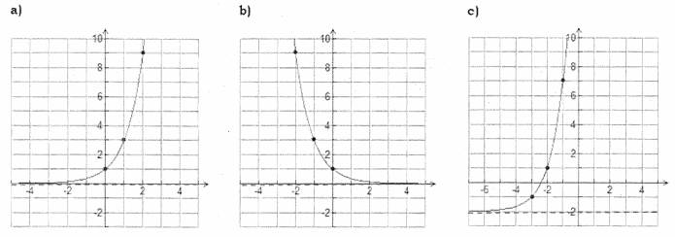

Ex2. Find the exponential function through (2, 16) and (6, 256) that has a horizontal asymptote at y = 0.

Ex3. Find the exponential function through (2, 10) and (4, 22) that has a horizontal asymptote at y = 4.

Ex4. Find an exponential function that passes through (3, 12.5) and (4, 11.25) and has a horizontal asymptote of
y = 10.

Ex5. The graph of $f\left(x\right)=2^{x}$is compressed vertically by a factor of $\frac{1}{2}$ reflected in the y-axis, and translated right 4 units and downward 5 units.
a) Write the equation of the new function.

b) State the domain, range, y-intercept and equation of the horizontal asymptote.

Ex6. The equation of the function that represents $f\left(x\right)={(\frac{1}{4})}^{x}$ after it is compressed horizontally by a factor of $\frac{1}{2}$, reflected in the x-axis, and shifted 4 to the left and 6 units up.
a) Write the equation of the new function.

b) State the domain, range, and equation of the horizontal asymptote.

