In this activity you will discover the graphical connection between $y=f\left(x\right)$and the functions of the form:
- $y=f\left(x\right)+c$, c is a constant
- $y=f(x-d)$, d is a constant
- $y=af\left(x\right), a$ is a constant and a > 0
- $y=f\left(kx\right), k$ is a constant and k > 0
- $y=-f\left(x\right)$
- $y=f\left(-x\right)$
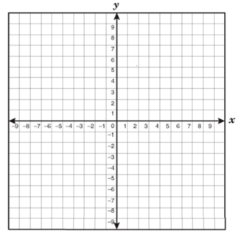
Investigation: Type $y=f\left(x\right)+c$

1. a. Sketch the graph of $f\left(x\right)=x^{2}$
b. On the same set of axes sketch the graphs of
- $y=x^{2}+2$
- $y=x^{2}-3$

c. If $y=f\left(x\right)$ is transformed to $y=f\left(x\right)+c$, where c is a constant, describe the transformation:
- if c > 0, then _________________________________

- if c < 0, then _________________________________

- Any point (x, y) under this transformation becomes ( , )

2. Using the pattern you discovered in 1c, sketch $y=f\left(x\right), y=f\left(x\right)+2, and y=f\left(x\right)-2$on the same set of axes for each of the following functions:

a. $f\left(x\right)=\left|x\right|$ | b. $f\left(x\right)=\sqrt{x}$
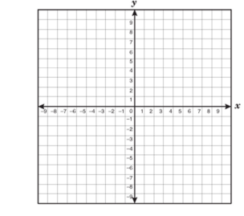

Investigation: Type $y=f(x-d)$

1. a. Sketch the graph of $f\left(x\right)=x^{2}$
b. On the same set of axes sketch the graphs of
- $y={(x-3)}^{2}$
- $y={(x+3)}^{2}$

c. If $y=f\left(x\right)$ is transformed to $y=f\left(x-d\right)$, where d is a constant, describe the transformation:
- if d > 0, then _________________________________

- if d < 0, then _________________________________

- Any point (x, y) under this transformation becomes ( , )

2. Using the pattern you discovered in 1c, sketch $y=f\left(x\right), y=f\left(x-2\right), and y=f\left(x+2\right)$on the same set of axes for each of the following functions:

a. $f\left(x\right)=\frac{1}{x}$ | b. $f\left(x\right)=x^{3}$

Try. State the transformations for: $y={(x+3)}^{2}-2$
COMMUNICATION
When a function is translated, we use key words such as translate (shift), units, up or down.
For example, $y={(x-2)}^{2}+1$ the parent function has been shifted 2 units right and 1 unit up.

__________________________________________________________________________________________

Horizontal & Vertical Translation Practice
1. Each of the following graphs show a shift of the function f that has formula $f\left(x\right)=x^{2}$.
Describe the shifts involved to obtain the function g.
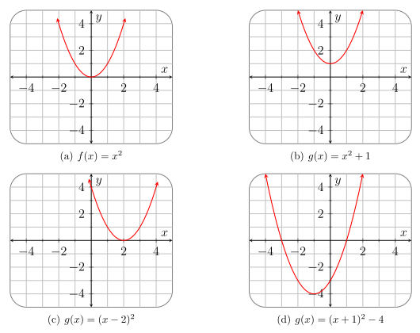
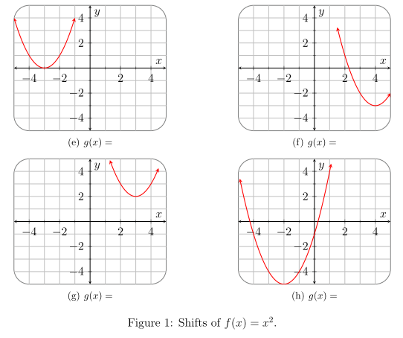

2. Consider the graph of f given in Figures 2 to 7. For the shifts given underneath the figures, state if they represent a horizontal or a vertical shift, and then sketch this shift on the axis provided.
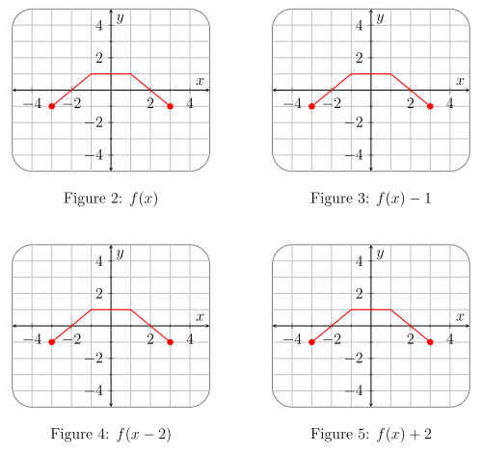
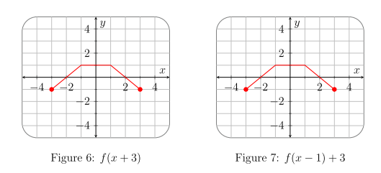

SUMMARY
In general, if f is a function and c is constant, then the graph of
$y=f\left(x\right)+c$is the graph of $y=f\left(x\right)$ shifted  - vertically upwards if c > 0  - vertically downwards if c < 0.  This is called an OUTSIDE CHANGE | $y=f\left(x-h\right)$is the graph of $y=f\left(x\right)$ shifted  - horizontally to the left if h > 0  - horizontally to the right if h < 0  This is called an INSIDE CHANGE

