CASE 1 – MINIMIZING SURFACE AREA: FIXED VOLUME, LOWEST SURFACE AREA
In the problem below, Guy is dealing with a situation where the volume is fixed and he needs to create a box with the lowest surface area so that he will spend the least amount of money in material.

Problem: Guy has 64 m³ of sand and wants to make a box to hold it, using as little material as possible. He sketches three boxes. Determine which box will have the least surface area?

Box 1 | Box 2 | Box 3
Volume = 64 m³  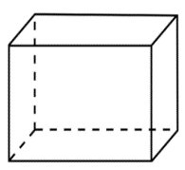  h = ____  w = 4m  l = 1m | Volume = 64 m³  h = ____  w = 4m  l = 2m | Volume = 64 m³  h = ____  w = 4m  l = 4m
SA = 2 (lw + wh + lh)  =  = | SA = 2 (lw + wh + lh)  =  = | SA = 2 (lw + wh + lh)  =  =

The closer the box gets to being a _____________, the smaller the surface area is for a given volume.

How to solve the problem above algebraically

We know that cube will provide the lowest surface area for a fixed volume of 64 m³ of sand. You need a calculator that has cube root button.
Tech Tip for
$$\sqrt[x]{}$$
1) Type 3 for the root
2) Press $\sqrt[x]{}$
3) Type 64

$$\sqrt[3]{x}$$
1) Type 64
2) Press $\sqrt[3]{x}$
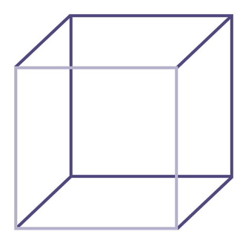

Example: State the dimensions that will minimize (lowest) the surface area of a shadow box that has a volume of 35937 cm³.
CASE 2 – MAXIMIZING VOLUME: FIXED SURFACE AREA, MAXIMUM VOLUME
In the problem below, Dorsa has a fixed amount of material (surface area) and needs to create a box that will provide the largest volume to fit the most amount of toys.

Dorsa has 24 m² of wood to make a toy box. Determine which box will have the maximum volume.

Box 1 | Box 2 | Box 3
Surface Area = 24 m²  h = 1.6  w = 4m  l = 1m | Surface Area = 24 m²  h = ____  w = 3m  l = 2m | Surface Area = 24 m²  h = ____  w = 2m  l = 2m
How to get h  SA = 2 (lw + wh + lh)  24 = 2 (1x4 + 4h + 1h)  24 = 2(4 + 5h)  24 = 8 + 10h  16 = 10h  1.6 = h | SA = 2 (lw + wh + lh)  =  = | SA = 2 (lw + wh + lh)  =  =
Volume Box 1:  V = l x w x h | Volume Box 2: | Volume Box 3:

The closer the box gets to being a _____________, the larger the volume is for a given surface area.

How to solve the problem above algebraically
We know that cube will provide the largest volume.

Determine the dimensions of a box that maximizes the volume and has a surface area of 54 cm².

Questions

1. A magician has ordered a covered water tank for his next new act. He has enough money to pay for 150 m² of building material. What is the largest volume of water that can be held in his water tank?

2. Dunstin and Carmila’s kids need a place to put all of their toys. Dunstin decides to build them a toy box, but he only has 54 cm² of wood to make the box. Will he be able to make a toy box and lid that will hold all the kids toys if they have a total volume of 32 cm³? (Do not worry about actual size of the toys, since smaller toys and fit amongst the larger ones).

3. State the dimensions that will minimize the surface area of a shadow box that has a volume of 19683 cm³.

4. You have been asked to make a single shelf cabinet, with a volume of 4.5 m. However it can only be 0.5 m deep.

- Determine the dimensions that will minimize the surface area.
b) Assuming that the front face of the shelf is open, what total surface area of wood is needed?

COMPLETE 495 # 1, 2, 3, 4 page 501 # 1, 2, 3, 5, 6

