|  |  |
| --- | --- |
|  | This is a _______________________________  Opposite sides are ____________________ and ____________________ |
|  | This is a _______________________________  It is also a ______________________________ with ___________________________________  _______________________________________ |
|  | This is a _______________________________  It is also a ______________________________ with _________________ _________________  ________________________________- |
|  | This is a _______________________________  It is also a ______________________________ with _________________ ________________ |
|  | This is a _________________________________  It has one pair of _____________________ ____________________ |
|  | This is a _________________________________  It has two pairs of _____________________ ____________________ ____________________ |

***Problem A:***

A quadrilateral has these coordinates: M(8, -3), A(-2, -8), T(-4, 3), and H(6, 8).

Graph this quadrilateral and complete the following questions.

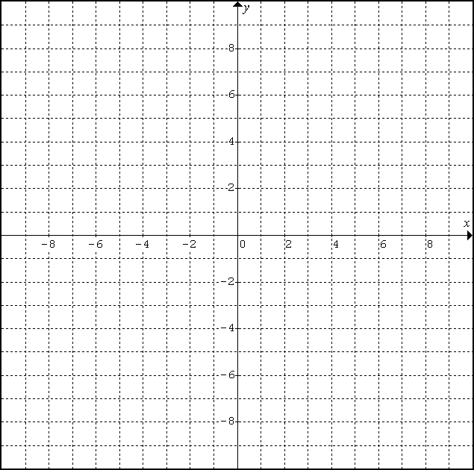

1. Determine the length of each side.

|  |  |  |  |
| --- | --- | --- | --- |
| MA | AT | TH | HM |
|  |  |  |  |

1. Determine the slope of each side.

|  |  |  |  |
| --- | --- | --- | --- |
| MA | AT | TH | HM |
|  |  |  |  |

1. Is MATH a parallelogram? Justify your answer with proper calculations (IE: how do you know).
2. Is MATH a rectangle? Justify your answer with proper calculations (IE: how do you know).
3. Is MATH a rhombus? Justify your answer with proper calculations (IE: how do you know).
4. Is MATH a square? Justify your answer with proper calculations (IE: how do you know).
5. Draw in the diagonals. Obviously, they are unequal in length. Verify this algebraically (IE: calculate the length of each diagonal and show they are unequal).
6. Determine the midpoint of each diagonal. What do you notice? What does this mean?

***Problem B:***

Points G(-6, 7), O(4, 3), N(2, -2), and E(-8, 2) form a quadrilateral.



1. Classify the quadrilateral.
2. Join the midpoints of each side to form another quadrilateral.
3. Verify that this ‘midpoint’ quadrilateral is a parallelogram.