**Review**: Find the equation in **standard form** of the quadratic function with zeros $(5+\sqrt{2 })$ and $(5-\sqrt{2 })$, and passes through the point (8, -3). Factored form: $y=a\left(x-r\right)(x-s)$.

**LESSON: SOLVING QUADRATIC EQUATIONS**

**Solve** means to find numerical value(s) for “x”.

***METHODS***

There are 3 widely used methods for solving quadratic equations.  Quadratic equations generally have 2 solutions (roots, x-intercepts).

**1) ISOLATION/SQUARE ROOT PROPERTY**

**Solve** for x: ${ x}^{2}-16=0$

|  |  |  |
| --- | --- | --- |
| **1** | Isolate the term that contains the squared variable. | $$x^{2}=16$$ |
| **2.** | Take the square root of both sides and solve for the variable. | $$\sqrt{x^{2}}=\sqrt{16}$$ |
| **3.** | Remember the possibility of two roots for every square root, one positive and one negative.  Place a  sign in front of the side containing the constant before you take the square root of that side. |  |

|  |
| --- |
| Solve the following function using the method of isolation: |

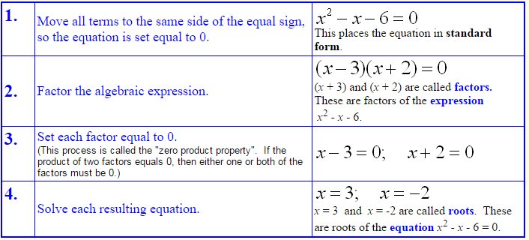**Method 2: FACTORING Solve** for x:

$x^{2}-x=6$

**Try**: 



**3) QUADRATIC FORMULA**Solve the following using quadratic formula:

Determine the *x* – intercepts of the function using the **quadratic formula**. Leave answers in exact reduced radical form (not decimal form).

**PRACTICE**

1. The town decides to build a rectangular fence around a playground. The playground without the fence measures 60 m by 40 m; however after the building of the fence, the area gets **doubled**. The designers put the fence around the playground with a uniform distance. Calculate the distance between the playground and the fence.

Playground

2. A factory is to be built on lot that measures 90 m by 70 m. A lawn of uniform width and with an area of 3900 m2 must surround the factory. What dimensions must the factory have? (Note that the lot is the factory plus the lawn)