SQUARE ROOTS & PERFECT SQUARES
To understand square roots, first let’s take a look at squares.

How to Square a Number: Just multiply it by itself.

Squares from 1² to 12² PERFECT SQUARES
1 Squared = 1² = 1 × 1 = 1  2 Squared = 2² = 2 × 2 = 4  3 Squared = 3² = =  4 Squared = 4² = =  5 Squared = 5² = =  6 Squared = 6² = =  7 Squared = 7² = =  8 Squared = 8² = =  9 Squared = 9² = =  10 Squared = 10² = =  11 Squared = 11² = =  12 Squared = 12² = = | 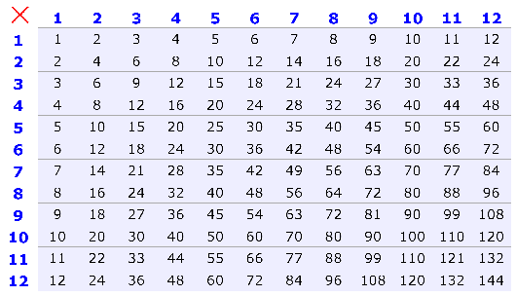

Square Roots:
A square root goes the other way:
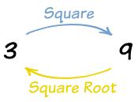
3 squared is 9, so a square root of 9 is 3

A square root of a number is a value that can be multiplied by itself to give the original number.
A square root of 9 is 3, because when 3 is multiplied by itself we get 9.
It is like asking “what can we multiply by itself to get this?”

The Square Root Symbol
$√$ This is the special symbol that means "square root". It is called the radical.

To Help You Remember: Think of the root of a tree.
$\sqrt{64}$4

$\sqrt{49}$4

$\sqrt{36}$4

$\sqrt{25}$4

$\sqrt{9}$4

$\sqrt{4}$4
$$\sqrt{81}$$
2 2
Or
-2 -2

OPERATIONS WITH SQUARE ROOTS
Just follow the same BEDMAS rule when operating with fractions.
Simplify each expression:
a) $\sqrt{25}+\sqrt{16}$ Read: Add the square roots of 25 and 16.

b) $\sqrt{3+6}$ Read: Square root the sum of 3 and 6. If there are more than one term inside the radical (square root sign), we simplify then square root.

c) $\sqrt{31+ \sqrt{25}}$ Read: Square root the sum of 31 and square root of 25. If there are more than one radical
start simplifying / evaluating from right to left.

d) $\sqrt{\sqrt{169}+ \sqrt{144}}$ Read: Square root the sum of square root of 169 and square root of 144.

e) 2$\sqrt{25}$ Read: 2 times square root 25.

f) 3$\sqrt{100}$ + 2$\sqrt{16}$ g) $\sqrt{12-\sqrt{6+ \sqrt{8+1}}}$

