INVESTIGATION: Type $y=af(x)$
1. On the same set of axes, sketch the graphs of $f\left(x\right)=\sqrt{x}, y=2f\left(x\right) and y=\frac{1}{2}f\left(x\right).$
0
$$x$$

1
4
9
$$\sqrt{x}$$

$$2\sqrt{x}$$

$$\frac{1}{2}\sqrt{x}$$

2. If $y = f(x)$ is transformed to $y=af(x)$, where a is a number, describe the transformation:
- If |a| > 1, then the parent function is __________ vertically by a factor of “|a|”.
- If 0 < |a| < 1, then it is ________________vertically ______________
Any point (x, y) under this transformation becomes ( , )
INVESTIGATION: Type $y=f(kx)$
1. On the same set of axes, sketch the graphs of $f\left(x\right)=\sqrt{x}, y=f\left(2x\right) and y=f\left(\frac{1}{2}x\right).$
$$x$$
0
0.5
2
4.5
$$\sqrt{2x}$$

$$x$$
0
2
8
18
$$\sqrt{\frac{1}{2}x}$$

4. If $y = f(x)$ is transformed to$y = f(kx)$, where k is a number, describe the transformation:
- If |k| > 1, then the parent function is _____________ horizontally by factor of “$\frac{1}{|k|}$”.
- If 0 < |k| < 1, then it is __________________________________
Any point (x, y) under this transformation becomes ( , ).

INVESTIGATION: Type $y=-f\left(x\right)$
1. On the same set of axes, sketch the graphs of $f\left(x\right) and-f\left(x\right).$
$$a. f\left(x\right)=|x|$$  x -|x|  -3  -2  -1  0  1  2  3 | b. $f\left(x\right)=\sqrt{x}$  x $$-\sqrt{x}$$  0  1  4  9
2. If $y=f(x)$ is transformed to $y=-f(x)$, where a is a negative number, describe the transformation:
I noticed that the graph is reflected about the “__” axis.
Any point (x, y) under this transformation becomes ( , ).

INVESTIGATION: Type $y=f(-x)$
3. On the same set of axes, sketch the graphs of $f\left(x\right) and f\left(-x\right).$
a. $f\left(x\right)=x^{2}$  x (-x)²  -2  -1  0  1  2 | b. $f\left(x\right)=\sqrt{x}$  x $$\sqrt{-x}$$  -9  -4  -1  0
4. If $y = f(x)$ is transformed to $y=f(kx)$, describe the transformation:
a) If k = -1, then the graph is reflected about the “__” axis.
Any point (x, y) under this transformation becomes ( , ).

Vertical stretches of f (x)
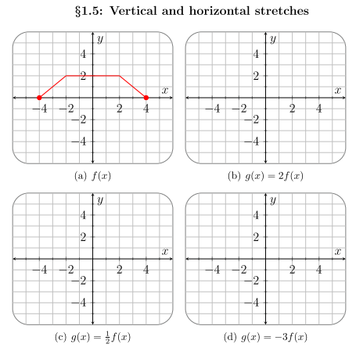
Horizontal Stretches of f (x)
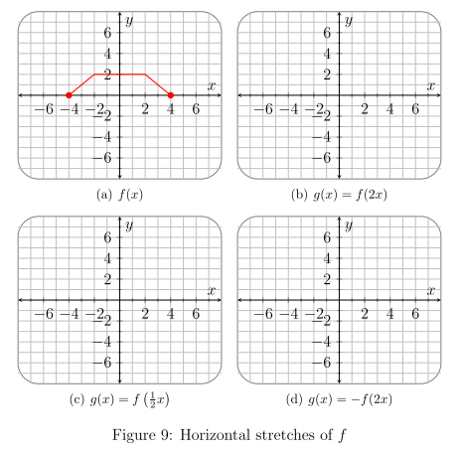

Let$f\left(x\right)=x^{2}$.
What do the following transformations represent in terms of stretches, reflections, and shifts?

a. $2f(x)$ | d. $-f(2x)$
b. 3$f(x)$ | e. $f\left(\frac{1}{3}x\right)+4$
c.$\frac{1}{2}f(x)$ | f. $-2f(x-1)$

Verify your answers using DESMOS or graphing calculator.

