DAY 1: TRENDS IN GRAPHS
1. Choose the graph that best represents the given description:
i) The number of bacteria in a laboratory colony increases over time, slowly at first and then more rapidly.
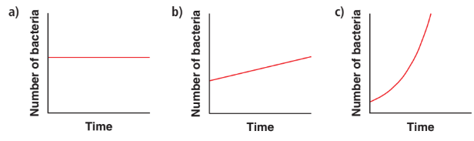

ii) The fuel used increases steadily as the distance driven increases.
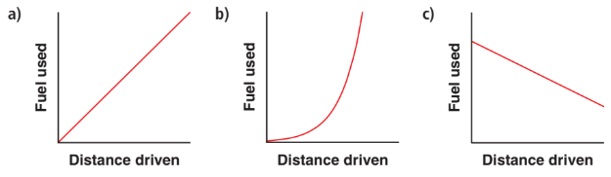

iii) As the price increases, the revenue earned increases, reaches a maximum, then decreases.
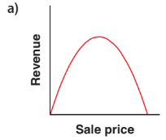 | 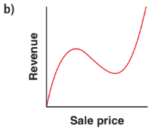 | 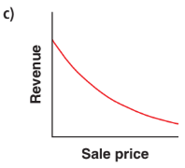 | 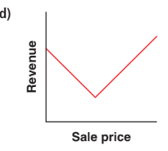

iv) The radioactive substance decayed over time, rapidly at first, then more slowly.
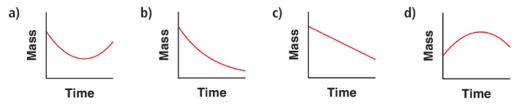

2. Match each graph with the statement that best describes it.
Which words gave clues about the shape of the graph?
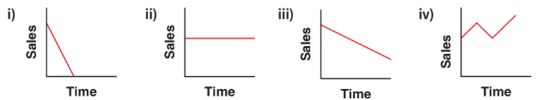
a) Sales have fallen dramatically over the last year.
b) Sales have fallen steadily over the last year.
c) Sales have remained constant over the last year.
d) Sales have fluctuated over the last year.

2. Describe the trends in each graph using the appropriate words including slow, rapid, increase, decrease, constant, at first, then, etc.

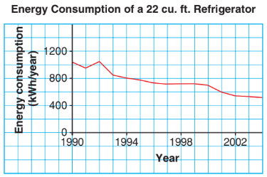
3. This graph shows the annual energy consumption of a new 22 cu. ft. refrigerator for each year.
a) Describe the trends in the graph.

b) In which year were refrigerators the most inefficient? How do you know?

c) Predict the annual energy consumption of a new refrigerator in 2010. Explain your prediction.

DAY 2: RATE OF CHANGE
4. For each table, name the variables independent (x) and dependent (y).

Calculate the average rate of change for the tables above including the units. What does the rate of change represent for each table?

5. For each graph, name the variables.
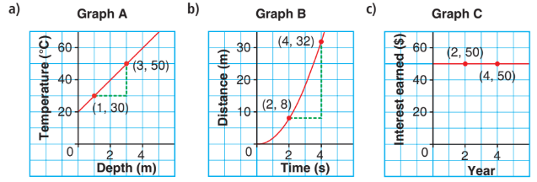
Determine the average rate of change between the indicated points on the graph. What does each rate of change represent?

6. Pippin is a financial advisor. He uses these tables to help his clients understand the difference between simple interest and compound interest.
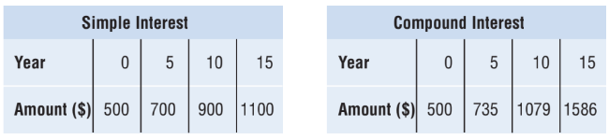
a) Graph the data in the tables. Describe the trends in each graph.
b) Calculate the average annual rate of change for consecutive pairs of data in each table.

DAY 3: LINEAR MODELS
7. Which tables of values model a linear relation? How do you know?

r | C
0 | 0.0
1 | 31.4
2 | 62.8
3 | 94.2
4 | 125.6
5 | 157.0
T | H
0 | 282.5
1 | 272.7
2 | 243.3
3 | 194.3
4 | 125.7
5 | 37.5

8. Which equations model a linear relation? How do you know?
a) y = 2x b) y = x² + 1 c) y= 5 - 2x

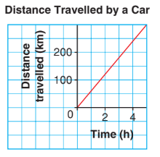
9. This graph shows how the distance a car travels changes over time.
a) Calculate the average rate of change. Recall, this is the slope (m).

b) What does the average rate of change represent?

c) What is the y-intercept on this graph? Recall, this is the initial value (b).

d) State the equation of this graph in y = mx + b form.

e) Calculate the distance travelled using in 10 hours using the equation above.

10. An energy auditor uses a temperature probe to check the insulation in a wall of a house.
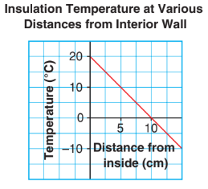
a) Calculate the average rate of change.

b) What does the average rate of change represent?

c) What is the y-intercept on this graph?

d) State the equation of this graph in y = mx + b form.

DAY 4: QUADRATIC MODELS
11. Which table of values models a quadratic relation? How do you know?
t | C
0 | 0.5
1 | 2
2 | 8
3 | 32
4 | 128

t | c
0 | 0.5
1 | 5.5
2 | 20.5
3 | 45.5
4 | 80.5

12. Which graphs might model a quadratic relation? Why do you think so/
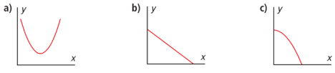

13. Which equations model a quadratic relation? How do you know?

14. Which of these equations models a quadratic relation? How do you know?
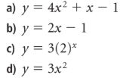

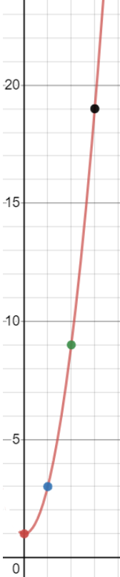
15. Determine if the graph shown represents a quadratic relation or not. Show/explain how you got your answer.

DAY 5: EXPONENTIAL MODELS
16. Which models represent exponential relations? Justify your answers.
t | A
0 | 35
1 | 25
2 | 15
3 | 5

d | P
0 | 51.2
1 | 64
2 | 80
3 | 100

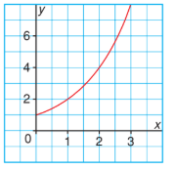
17. Does the following graph represent exponential relation? Justify your answer.

18. Which of the following equations is exponential relation?
a) y = 10(2)^{x} b) y = 10x² c) y = 2 + 4x d) y = 2(4)^{x}

19. A city council wants to discourage illegal parking. It has two plans.
Plan A: A $10 fine for the first offence. The fine increases by $20 for each subsequent offence.
Plan B: A $10 fine for the first offence. The fine doubles for each subsequent offence.

a) Create a t-chart (table of values) for each plan and then determine the cost of a 4th fine under each plan.
b) What type of growth does each plan illustrate?

Year | # of Subscribers
2000 | 15900
2001 | 20670
2002 | 26871
2003 | 34923.3
2004 | 45411.99
20. This table shows the growth in cell phone subscribers for a particular company.
a) What is the initial amount (a) of subscribers? ______
b) What is the growth factor (b)? _______
c) Determine the exponential relation y = ab^{x} that best fits the data, where x is the number of years since 2000 and y is the number of cell phone subscribers.

d) Based on the equation above, estimate the number of subscribers in the year 2010.

21. A camera stores charge in a capacitor and then uses it to create light when a flash is needed. This table shows the charge left in the capacitor after the flash begins.
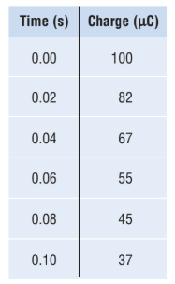
a) Create a scatter plot of the data and describe any trends.

b) Using DESMOS, determine the exponential relation y = ab^{x} that best fits the data, where y is the charge left in the capacitor, in microcoulombs, after x seconds.

c) Using the equation above, estimate the charge left in the capacitor after 0.20 seconds.

Time (min) | Volume  (L)
0 | 1.5
10 | 1.7
20 | 1.9
30 | 2.2
40 | 2.5
50 | 2.8
60 | 3.2
22. The volume of dough for cinnamon buns is measured at 10 min intervals.
a) Using DESMOS, determine the exponential relation y = ab^{x} that best fits the data, where y is the volume of dough, in litres, after x minutes.

d) Estimate the volume of dough after each length of time using the equation above.
i) 45 min ii) 90 min

