Determine the vertex for each quadratic expression:

|  |  |  |  |
| --- | --- | --- | --- |
| $y=\left(x+2\right)(x-4)$ | | |  |
| x-intercepts/zeros: | | Vertex: |
|  | | |  |
| x-intercepts/zeros: | Vertex: | |
|  | | |  |
| x-intercepts/zeros: | Vertex: | |
|  | | |  |
| x-intercepts/zeros: | Vertex: | |

|  |
| --- |
| **Summary**:  To find the vertex by averaging the zeros, you:   1. ______________________________________________ to get the x-coordinate 2. ______________________________________________ to get the y-coordinate. |

**Examples**

1. 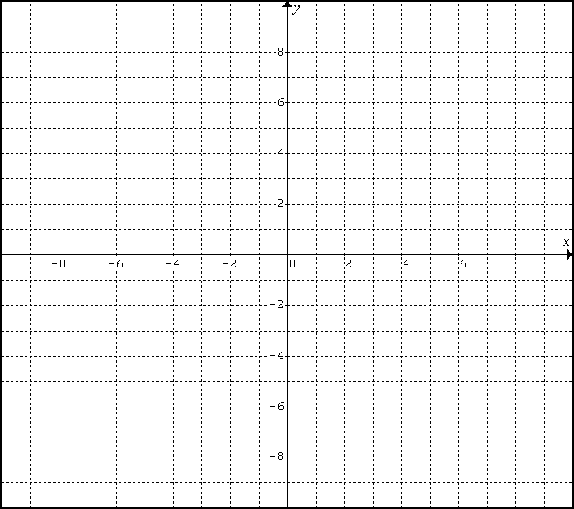Given y = ½(x – 2)(x + 4),

a. State the zeros: __________

b. Determine the x-coordinate of the vertex: __________

*(average the zeros)*

b. Determine the y-coordinate of the vertex: __________

*(substitute)*

c. Graph using the zeros and vertex.

1. Given y = 2(x + 5)(x + 1),

a. State the zeros: __________

b. Determine the x-coordinate of the vertex: __________

*(average the zeros)*

b. Determine the y-coordinate of the vertex: __________

*(substitute)*

c. Graph using the zeros and vertex.

1. Determine the zeros and vertex of y = -3x2 +12x by averaging the zeros.
2. Determine the zeros and vertex of y = 2x2 – 12x – 32 by averaging the zeros.
3. Determine the zeros and vertex of y = 4x2 – 16x + 7 by averaging the zeros. You can find the zeros by factoring or using the formula.

***Application:*** When a football is kicked its height *h* metres, after *t* seconds is given by the equation . Determine the maximum height of the ball by averaging the zeros.