**Stretched vertically by a factor of a**

* If a > 1, the graph is expanded
* If 0 < a < 1 the graph is compressed
* If a < 0, the graph is reflected in the x-axis

**Translated vertically c units**

* If c > 0, the graph shifts up
* If c < 0, the graph shifts down



**Translated horizontally d units**

* If the sign is negative, the graph shifts to the right
* If the sign is positive, the graph shifts to the left

**Stretched horizontally by a factor of 1/k**

* If k >1, the graph is compressed
* If 0 < k < 1 the graph is expanded
* If k < 0, the graph is graph is reflected in the y-axis

The *a* affects the graph  by stretching or compressing ___________________ by a factor of *a*.

If the a is negative, there is a vertical reflection about the __________________.

The d affects the graph  by translating ______________________ d units.

The c affects the graph  by translating ______________________ c units.

The *k* affects the graph  by stretching or compressing ____________________ by a factor of .

If the *k* is negative, there is a horizontal reflection about the _________________.

**\*Does the order of transformations matter?**

**Graphing: Mapping Notation**

|  |
| --- |
| If you can successfully figure out the mapping notation for the transformed function, the graphing part is rather easy. Here is the formula below. $$y=af[k\left(x-d\right)]+c$$ **(x,y) 🡪**  **Ex1** State the mapping notation for $y=3f\left[-2\left(x-1\right)\right]+1$; then transform point (4, 4).    **Ex2** State the mapping notation for $y=-\frac{1}{2}f\left[-\frac{1}{2}\left(x+1\right)\right]-1;$ then transform point (1, 2). |

**Example 1 – Sketching Graphs of Transformed Functions**

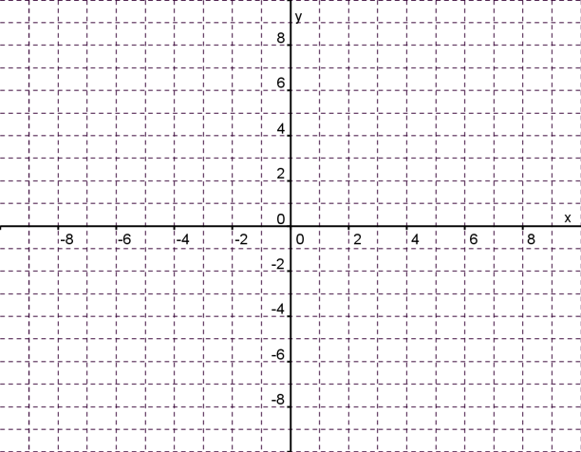1. Given the function, $f\left(x\right)=|x|$, state the mapping notation for $g\left(x\right)=-2f\left(x-6\right)+4,$ then graph the transformed function. State the domain and range.

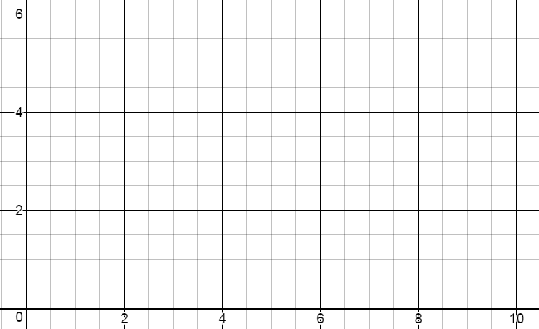2. Graph $f\left(x\right)=\sqrt{2x-4}+1$. State the domain and range.   
**Hint:** Rewrite 2x - 4 in factored form to determine the horizontal translation.

**Example 2 – Writing Equations of Transformed Functions**

1. The function $y=f(x)$ has been transformed into $y=af[k\left(x-d\right)]+c$. Write the following in the appropriate form:  
(a) a reflection about the x axis, a vertical compression by a factor of ½ and a translation 3 units right.

(b) a reflection about the y axis, a vertical stretch by a factor of 3, a horizontal stretch by a factor of 2, a translation left 5 and up 4.

**Practice Transformations Given an Equation**

Graph each of the following functions by:

1. Graphing the base function first.
2. Listing the transformations.
3. Applying the transformations to the base function.

|  |  |  |
| --- | --- | --- |
| **1)** | **2)** | **3)** |
|  |  |  |
| **4)** | **5)** | **6)** |
|  |  |  |
| **7)** | **8)** | **9) $y=2\sqrt{2x+2}-2$** |
|  |  |  |

**Practice Transformations Given a Graph**

List the transformations.

Apply the transformations to key points on the graph.

|  |  |
| --- | --- |
| **1)** | **2)** |
|  |  |
| **3)** | **4)** |
|  |  |
| **5)** | **6)** |
|  |  |
| **7)** | **8)** |
|  |  |