

**I'm in the Mood for some Fun!**

|  |
| --- |
| **Warm-Up:** What Do I Do? *A SOHCAHTOA Dilemma*  Solve for x. |

|  |  |  |
| --- | --- | --- |
| 1. Find the length of AC.    *Step 1:* Use **ΔBCD** to find **CD**  *Step 2:* Use **ΔACD** to find **AC** | 2. Find the measure of .    *Step 1:* Use Δ __________ to find __________  *Step 2:* Use Δ __________ to find __________ | |
| 3. Find the length of JL.    *Step 1:* Use Δ __________ to find __________  *Step 2:* Use Δ __________ to find __________ | 4. Find the measure of .    *Step 1:* Use Δ __________ to find __________  *Step 2:* Use Δ __________ to find __________ |
| **Day 9**  3. A 3-dimensional problem:  Some measurements were taken by a surveyor, as shown on the diagram, to find the measurement of an inaccessible height. Find the height of the cliff.  What do you need to assume to do this question? |  |

2. A 53 m high transmission tower has a supporting guy wire that makes an angle of 68˚ with the ground. The company that maintains the tower wishes to move the base of the guy wire 4 m farther from the base of the tower.

* 1. How much additional wire is needed? (2 m)
  2. What angle will the wire make with the ground at its new position? (64˚)

**1.** Kim and Yuri live in apartment buildings that are 30m apart, as shown. The angle of depression from Kim’s balcony to where Yuri’s building meets the ground is 400.

The angle of elevation from Kim’s balcony to Yuri’s balcony is 200

1. How high is Kim’s balcony about the ground, to the nearest meter?

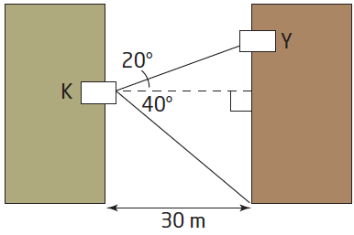

1. 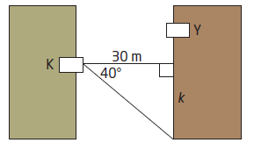How high is Yuri’s balcony above the ground, to the nearest meter?

