1. Determine the equation of a horizontal line that goes through (1, -3) and state its slope.
2. Determine the equation of a vertical line that goes through (1, -3) and state its slope.
3. The slope of line x = -3 is _________
4. The slope of line y = -4 is zero

a) True b) False

1. The line perpendicular to  is:

|  |  |  |  |  |
| --- | --- | --- | --- | --- |
| a) | b) | c) | d) | e) |

1. The line perpendicular to line y = - 4 is:

|  |  |  |  |  |
| --- | --- | --- | --- | --- |
| a) | b) | c) | d) | e) |

1. **Identify** whether each of the following pairs of lines are parallel ( || ), perpendicular ( ⊥ ), or neither (N). [K4]

a) 

b) 

c) 

d) 

1. **Solve** the system below using ONLY the intercepts. [Solve = State POI in a therefore statement]

(A) 3 (B)

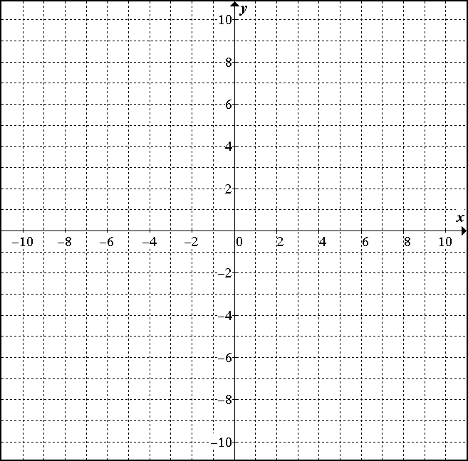

7. Determine the **slope** and **y-intercept** of the line given below. [Rearrange the given equation into y=mx+b]

8. Fill in the blanks in the table below:

|  |  |  |  |
| --- | --- | --- | --- |
| **Equation** | **b** | **m** | **Slope of a line perpendicular** |
|  |  |  |  |
|  | 6 | 0 |  |
|  |  |  |  |
|  | -3 |  | 4 |
|  |  |  |  |

9. Aurora High School is having a fall dance. Last year, 190 students attended and the total cost was $1250. Two years ago 175 people attended and the total cost was $1175.

a) Determine the cost of a ticket.

b) Determine the fixed cost of running the dance.

c) Determine the equation modelling this situation. Use variables C and n.

d) If 225 people attend this year’s dance, what would be the total cost?