INVERSE OF A RELATION | INVERSE OF A LINEAR FUNCTION
INVESTIGATE:  a) Plot the points: A(−4, 2) B(−2, 0), C(0, 5), D(2, 5), E(3, 7)  b) Join the points in order, from A to E, using straight line segments.  c) State the Domain (D) and Range (R) of this function.  D =  R =  d) Interchange the Domain and Range and re-plot the points.  A(−4, 2) becomes A' (2, −4)  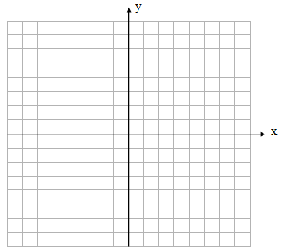  e) Again, join the points in order from A' to E'.  f) State the Domain and Range of the new relation.  This is called the INVERSE relation of the original.  D =  R =  g) Is the new relation also a function? Why or why not?  h) Graph the line y = x  i) How does the original function and its inverse seem to be related to the line y = x? | INVESTIGATE:  a) Graph the linear function: y = 2x + 4  b) Interchange the x and y in the above equation and rearrange it to solve for y.  Step 1: x = 2y + 4  c) The result is the inverse equation for the original function: y = 2x + 4:  _________________  d) Is the inverse also a function? If so, what type?  e) Graph the inverse and state how it is related to the original function and the line y = x.  g) State the Domain and Range for both y = 2x + 4 and for its inverse.  h) Find the inverse equation for the linear function:$y=-\frac{2}{3}x+6$

INVESTIGATE: Inverse of a Quadratic Function
a) Graph the quadratic function: y = x² + 3
b) State its Domain and Range.
D =
R =
c) Graph the inverse of this function by interchange x and y values for each point.
d) Is the inverse a function?
e) State the Domain and Range for the Inverse.
D =
R =
f) Find the Inverse Equation by interchanging x and y in the original equation and isolating y.
x = y² + 3

g) Sometimes, the inverse of a function is not also a function. In these cases, we restrict the domain of the original function so that its reflection in the line y = x is also a function.
If a relation is a function, the notation: f(x) may be used. If a function's inverse is also a function, the notation: f⁻¹(x) is used. Note that f⁻¹ is not an exponent; therefore, it is not 1/f
For y = x² + 3 the domain would be: $\{xϵR|x≥0\}$. We are restricting the x values that are less than 0 so that the inverse function can pass the VLT test. In other words, when you graph the function, just draw the right arm of the parabola because it is where the x values are greater than or equal to 0.
a) Restrict the left arm, then inverse the function  $$y=x^{2}+3 D=\{xϵR|x≥0\}$$ | a) Restrict the right arm, then inverse the function  $$y=x^{2}+3 D=\{xϵR|x≤0\}$$

Practice
1. Find the inverse for each relation.
a) {(1, -3), (-2, 3), (5, 1), (6, 4)} b) {(-5, 7), (-6, -8), (1, -2), (10, 3)}

2) Find an equation for the inverse for each of the following relations.
a) y = 3x + 2 b) y = -5x - 7 c) $y=\frac{3}{4}x+5$

d) $y=x^{2}-4$D = {x$ϵR|x≤0\}$ e) $y=x^{2}-4$D = {x$ϵR|x≥0\}$ f) $y=\sqrt{x-2}$, $y≥0$

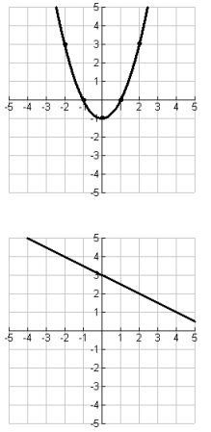 | 