- Sydney Harbour Bridge in Australia is usually wide for a long-span bridge. It carries two rail lines, eight road lanes, a cycle lane, and a walkway.

  - Factor the expression 10x2 − 7x − 3 to find the length and the width of the bridge.

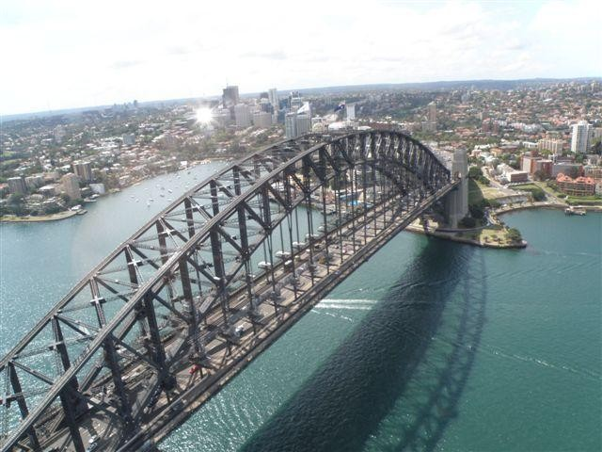

  - If x represents 50 m, what are the length and the width of the bridge, in metres?

- The height of a ball thrown from the top of a building can be approximated by the formula
h = −5t 2 +15t + 20, where t is the time, in seconds, and h is the height, in metres.
Write the formula in factored form. How long does it take for the ball to reach the ground?

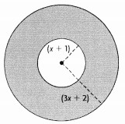
- Determine a simplified factored expression for the area of shaded region.

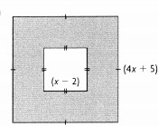
b.

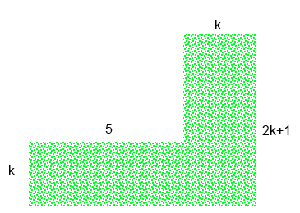
c.

d.
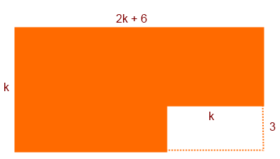

4. The volume of a rectangular prism is represented by the polynomial 2x³ - 24x² + 72x.
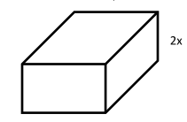
a. Factor the polynomial completely to determine the dimensions of the prism.
Remember that V = lwh

b. If x represents 8 cm, what are the possible dimensions of the prism?

c. Could x represent 5 cm? Explain.

5. Write a polynomial with three terms that when factored has a GCF of 3x⁴y²z.

6. Determine a possible value of k such that x² +kx - 10 can be factored as a simple trinomial.

