 ***A Dental Dilemma***

|  |
| --- |
| download**[http://t1.gstatic.com/images?q=tbn:ANd9GcScy7LsBXdnU0ZXuyZawDGiuEWyk6-YmHd5yWV15gkzkDqVa77DyQ](http://www.google.ca/imgres?q=laptop+clip+art&hl=en&biw=1107&bih=617&gbv=2&tbm=isch&tbnid=NCV1SFw5DngSLM:&imgrefurl=http://www.computerclipart.com/computer_clipart_images/laptop_computer_coloring_page_0521-1004-3015-4009.html&docid=8PRvVSxIIGKSiM&w=300&h=270&ei=yjpDTorsDpDegQfRx-HGCQ&zoom=1)** **Open**: Desmos App |

We will be examining things in real life that are parabolic in shape. One thing would be your teeth!

Dentists describe the arrangement of human teeth as a **parabolic dental arcade**.

1. Take a sheet of paper, and bite down on it at the corner. Be careful not to get a paper cut!!
2. Cut out the ‘parabolic shape’ that your teeth formed.
3. Trace your ‘teeth parabola’ on the grid provided. In between your front two teeth (your incisors) should be where the vertex is. The y-axis will be the axis of symmetry. Make the direction of opening of your ‘teeth parabola’ up.

|  |  |
| --- | --- |
| **x** | **y** |
|  |  |
|  |  |
|  |  |
| 0 | 0 |
|  |  |
|  |  |
|  |  |
|  |  |

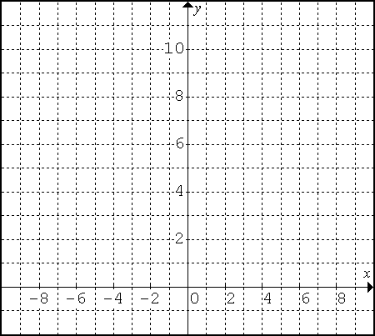

1. Locate 7 coordinates on your ‘teeth parabola’. One should of course be (0, 0). Include 3 points on the left of the axis of symmetry and 3 points on the right. State the coordinates of each of these points in the table provided.

**Quadratic Regression** the process of modeling the relationship between the independent *x* variable and the dependent *y* variable using a quadratic relation. This process produces an equation that relates the value of *x* to the value of *y*.

* Using DESMOS, click C:\Users\x201t\Desktop\Math Site Images\MPM2D1\plus2.PNG, then C:\Users\x201t\Desktop\Math Site Images\MPM2D1\table.PNG. Enter all of the *x*-coordinates in the *x* column and all of the

*y*-coordinates in the *y* column.

* Desmos will **PLOT** the points for you. Does the scatter-plot look like the one above?
* Click **Add Item**C:\Users\x201t\Desktop\Math Site Images\MPM2D1\plus2.PNG, thenC:\Users\x201t\Desktop\Math Site Images\MPM2D1\f(x) expression.PNG. Type **y1**, desmos will write it as **y1**, you can find **~** by clicking keypad then C:\Users\x201t\Desktop\Math Site Images\MPM2D1\ABC.PNG, clickC:\Users\x201t\Desktop\Math Site Images\MPM2D1\~.PNG. Type the rest of the equation and should it like this vertex.PNG

Desmos attempts to draw the best parabola (i.e. Parabola of Best Fit) through your points.

1. State the equation of your dental parabola in **vertex form $y={a\left(x-h\right)}^{2}+k$**. You will need to substitute the **a**, **h**, and **k** values into the equation.

__________________________________________

1. The “Correlation coefficient” indicates how closely your data resembles a true parabola. A correlation coefficient of **1.0** represents a perfect parabola. What is your correlation coefficient? (It’s your **R2** value)

____________________

1. How well do you think your teeth resemble a parabola? Explain.

**Task 1: Ron’s Run**

The coach of a basketball team had his players practise the following warm-up activity: Run towards the wall; touch it; then run back. To analyse their run, he placed a motion detector to record their efforts. The coach triggers the detector on as a player passes it. The following table is collected for Ron’s run.

1. **Complete the table of values. Is this relationship linear or quadratic? How do you know?**
2. Create a scatter plot of this data.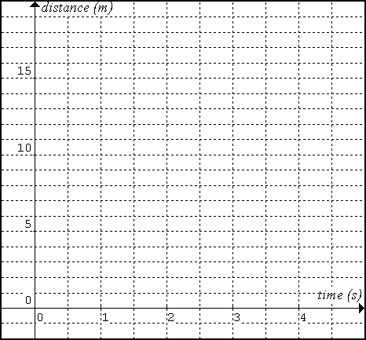

|  |  |  |  |
| --- | --- | --- | --- |
| **Time Elapsed (s)** | **Distance from Detector (m)** | ***finite differences*** | |
| **1st Diff.** | **2nd Diff.** |
| 0 | 0 |
|  |
| 0.5 | 7 |  |
|  |
| 1 | 12 |  |
|  |
| 1.5 | 15 |  |
|  |
| 2 | 16 |  |
|  |
| 2.5 | 15 |  |
|  |
| 3 | 12 |  |
|  |
| 3.5 | 7 |  |
|  |
| 4 | 0 |  |
|  |  |

1. Does this parabola open up or down?

How do the finite differences tell you?

|  |  |  |
| --- | --- | --- |
| **Point** | **Value** | **Relation to Word Problem** |
| y-intercept |  |  |
| zeros |  |  |
|  |  |
| vertex |  |  |
| axis of symmetry |  |  |
| max/min |  |  |

1. Complete the following table.

Label each item on the graph.

**Task 2: A Cagey Problem**

Old McDonald had a farm, EIEIO. And on that farm he had some chickens, EIEIO. He is going to cage up his chicken area, but he only has 120 metres of fencing. The chicken area is to be as large as possible and it must be completely surrounded by the fencing.

|  |  |  |  |
| --- | --- | --- | --- |
| **If the length of one side is…**  (in metres) | **Diagram**  (not drawn to scale) | **Then the width of the other side is…**  (make sure it all adds to 120!)  (in metres) | **And the area is…**  (length×width)  (units are m2) |
| 5 | 5  5  55  55 |  |  |
| 15 |  |  |  |
| 25 |  |  |  |
| 35 |  |  |  |
| 45 |  |  |  |
| 55 |  |  |  |

1. Complete the table. Remember: The perimeter must always add up to 120!!
2. Graph the data on the next page. Draw in the parabola of best fit.
3. What is the maximum area?
4. What do the length and width need to be to obtain that maximum area?
5. Use the **DESMOS** to determine the algebraic model of the relationship between the length and area.

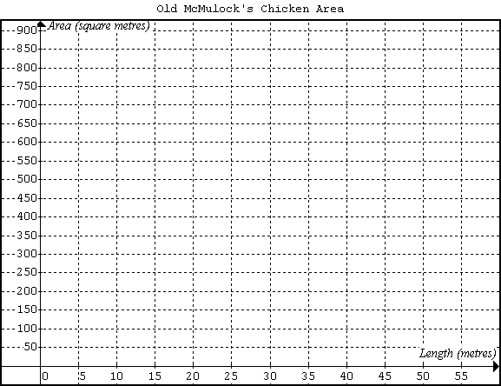

1 Old McDonald's Chicken Area

**Task 3: Tickets, Anyone?**

|  |  |  |
| --- | --- | --- |
| **Ticket Price ($)** | **Number of People** | **Total Money From Tickets ($)** |
|  |  |  |
|  |  |  |
|  |  |  |
|  |  |  |
|  |  |  |
| 28 | 220 |  |
| 29 | 210 |  |
| 30 | 200 | 30 × 200 = $6000 |
| 31 | 190 |  |
|  |  |  |

The promotions manager of a new band is deciding how much to charge for concert tickets. She has calculated that if the tickets are $30 each, then 200 people will come to the concert. For every $1 increase in the price, 10 less people will come. Create a table to calculate how much should be charged to MAXIMIZE the revenue from the ticket sales.

1. What is the maximum amount of money that can be earned?

____________________

1. What should they sell the tickets for to earn that maximum area?

____________________

1. Use the **Desmos** to determine the algebraic model of the relationship between the ticket price and total money.

______________________

