Trigonometric Ratios for Special Angles

There are 2 kinds of right triangles that create interesting trigonometric ratios. They are:

The  Triangle









The  Triangle (version 1)

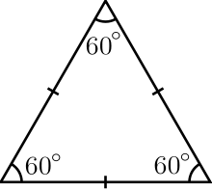







The  Triangle (version 2)







Trigonometric Ratios for Special Angles continued...

* SPECIAL ANGLES and their values can be used to solve a variety of problems. Suggestion: Don’t worry about memorizing the trig ratios, you can always MATHEMATISE them if you know the triangles.

|  |
| --- |
| **NOTE:**  **NOT** |

**Example** **1** – Evaluate the following expressions using exact values – ***no calculator & no decimals!***

a)  b) 

c)  d) 

**Example** **2** – Using exact values, determine $θ$ if $0°≤θ≤90°$

|  |  |  |  |
| --- | --- | --- | --- |
| a) $\sqrt{2}\sin{θ}-1=0$ | b) $2\cos{θ}-\sqrt{3}=0$ | c) $4 \cos^{2}θ-1=0$ | d) $\tan^{2}{θ}-3=0$ |

**Extending**

**THREE RECIPROCAL**

**TRIG RATIOS**







a. If $\cot{∝=\sqrt{3}, calculate (\sin{∝)(\cos{∝)-\cos^{2}∝exactly.}}}$

b. If $\csc{β=2 , calculate \frac{\tan{β}}{\sec{β}}-\sin^{2} β exactly.}$