|  |  |
| --- | --- |
| * Enough steps shown to clearly demonstrate thinking * Solutions that are neat and easy to follow * Proper use of mathematical symbols * Equal signs aligned | * Units used as required * Concluding statements for all word problems * Fractions reduced to lowest terms * Correct rounding. |

1. The volume of a cone is 900 in3. The height is four times the radius of the cone. What is the radius of the cone?

2. Calculate the volume and surface area of the shape below.

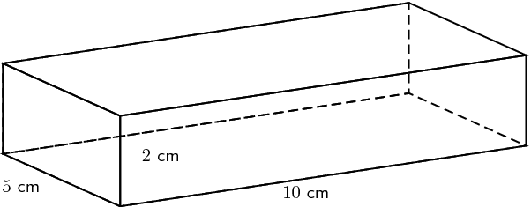

3. Determine the volume and surface area of the shape below, rounded to one decimal place.

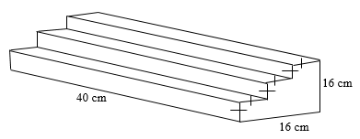

4. A cylindrical can of tomato paste designed to have a minimum surface area. It has a volume of 600 in.3

a) Calculate the optimal dimensions: radius and height

b) Calculate the minimum surface area. Round all measurements to 1 decimal place.

5. Convert the following measurements, rounded to 2 decimal places:

|  |  |  |
| --- | --- | --- |
| 27 in. = __________ ft. | 320 m = ____________ km | 2.2 lb = __________ g |

**6.** How much air is inside this empty house, which is made up of a rectangular prism base and a triangular prism roof?



**Complete:** p. 120 #1c, 7, 9d, 10d, 11, 12, 15, 16, 18, 19

**Metric and Imperial Conversions**

|  |  |  |  |  |
| --- | --- | --- | --- | --- |
|  | Multiply by |  |  | Divide by |
| ft 🡪 in | 12 |  | in 🡪 ft | 12 |
| yd 🡪 ft | 3 |  | ft 🡪 yd | 3 |
| yd 🡪 in | 36 |  | in 🡪 yd | 36 |
| mi 🡪 yd | 1760 |  | yd 🡪 mi | 1760 |
| mi 🡪 ft | 5280 |  | ft 🡪 mi | 5280 |

|  |  |  |  |  |
| --- | --- | --- | --- | --- |
|  | Multiply by |  |  | Divide by |
| Tbsp 🡪 tsp | 3 |  | tsp 🡪 Tbsp | 3 |
| cup 🡪 Tbsp | 16 |  | Tbsp 🡪 cup | 16 |
| pt 🡪 cups | 2 |  | cup 🡪 pt | 2 |
| qt 🡪 pt | 2 |  | pt 🡪 qt | 2 |
| gal 🡪 qt | 4 |  | qt 🡪 gal | 4 |
| lb 🡪 oz | 16 |  | oz 🡪 lb | 16 |
| t 🡪 lb | 2000 |  | lb 🡪 t | 2000 |

|  |  |  |  |  |  |  |  |
| --- | --- | --- | --- | --- | --- | --- | --- |
| Unit | Abbreviation |  | grams |  | Litres |  | Metric Examples  1. km 🡪 hm 1 jump down x 10 2. km 🡪 m 3 jumps down x 1000 3. mm 🡪 dm 2 jumps up  100 |
| kilometre | km |  | kg |  | kL |  |
| hectometre | hm |  | hg |  | hL |  |
| decametre | dam |  | dag |  | daL |  |
| metre | m |  | g |  | L |  |
| decimetre | dm |  | dg |  | dL |  |
| centimetre | cm |  | cg |  | cL |  |
| millimetre | mm |  | mg |  | mL |  |

Imperial 🡪 Metric Metric 🡪 Imperial

|  |  |  |  |  |
| --- | --- | --- | --- | --- |
|  | Multiply by |  |  | Divide by |
| in 🡪 cm | 2.54 |  | cm 🡪 in | 2.54 |
| ft 🡪 m | 0.3048 |  | m 🡪 ft | 0.3048 |
| yd 🡪 m | 0.9144 |  | m 🡪 yd | 0.9144 |
| mi 🡪 km | 1.609 |  | km 🡪 mi | 1.609 |
| sq ft 🡪 sq m | 0.0929 |  | sq m 🡪 sq ft | 0.0929 |
| sq yd 🡪 sq m | 0.8361 |  | sq m 🡪 sq yd | 0.8361 |

|  |  |  |  |  |
| --- | --- | --- | --- | --- |
|  | Multiply by |  |  | Divide by |
| oz 🡪 g | 28.35 |  | g 🡪 oz | 28.35 |
| lb 🡪 g | 453.6 |  | g 🡪 lb | 453.6 |
| lb 🡪 kg | 0.4536 |  | kg 🡪 lb | 0.4536 |
| fl oz 🡪 mL | 29.575 |  | mL 🡪 fl oz | 29.575 |
| gal 🡪 L | 3.785 |  | L 🡪 gal | 3.785 |
| qt 🡪 L | 0.9463 |  | L 🡪 qt | 0.9463 |
| pt 🡪 L | 0.4731 |  | L 🡪 pt | 0.4731 |

**Formula Sheet 2-Dimensional Shapes**

|  |  |  |
| --- | --- | --- |
| **Geometric Figure** | **Perimeter** | **Area** |
| **Rectangle** |  |  |
| **Parallelogram** |  |  |
| **Triangle** |  |  |
| **Trapezoid** |  |  |
| **Circle** |  |  |

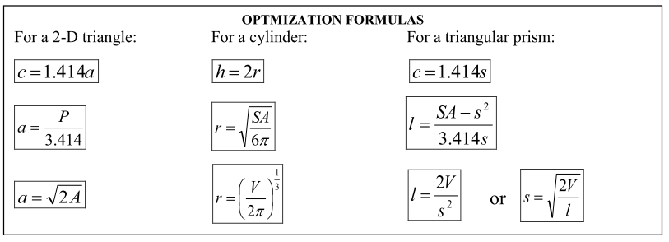

**Formula Sheet**

**3-Dimesional Shapes**

|  |  |  |
| --- | --- | --- |
| **Geometric Figure** | **Surface Area** | **Volume** |
| **Cylinder** |  |  |
| **Sphere** |  |  |
| **Cone** |  |  |
| **Square-based Pyramid** |  |  |
| **Rectangular Prism** |  |  |
| **Triangular Prism** |  |  |