1. Calculate the average rate of change for the tables above including the units. What does the rate of change represent for each table?

|  |  |  |
| --- | --- | --- |
|  |  |  |

2. Identify each graph as linear, quadratic or none. Write your answer in the lines to the right.

a)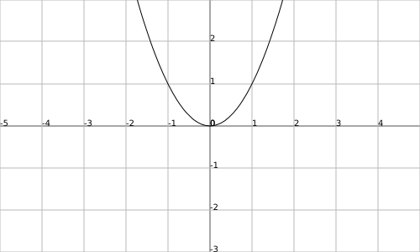 b) 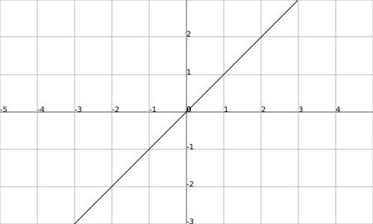 c) 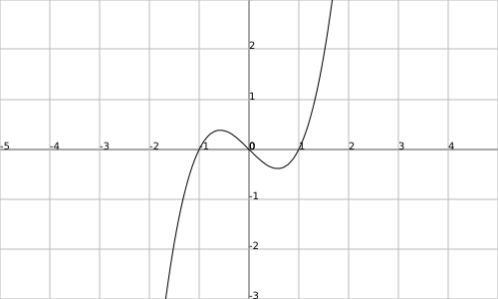

TYPE OF RELATION:

1. _______________
2. _______________
3. _______________

3. Calculate the 1st differences: b) Calculate the 2nd differences: c) Calculate the growth/decay factor:

|  |  |  |  |  |  |  |  |  |  |  |  |  |  |  |  |  |  |  |  |  |  |  |  |  |  |  |  |  |  |  |  |  |  |  |  |  |  |  |
| --- | --- | --- | --- | --- | --- | --- | --- | --- | --- | --- | --- | --- | --- | --- | --- | --- | --- | --- | --- | --- | --- | --- | --- | --- | --- | --- | --- | --- | --- | --- | --- | --- | --- | --- | --- | --- | --- | --- |
| |  |  | | --- | --- | | ***x*** | ***y = 3x*** | | -1 |  | | 0 |  | | 1 |  | | 2 |  | | 3 |  | | |  |  | | --- | --- | | ***x*** | ***y = x2*** | | -1 |  | | 0 |  | | 1 |  | | 2 |  | | 3 |  | | |  |  | | --- | --- | | ***x*** | ***y = 3x*** | | -1 |  | | 0 |  | | 1 |  | | 2 |  | | 3 |  | |

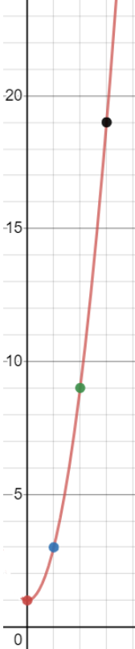

4. Determine if the graph shown represents a quadratic relation or exponential. Show/explain how you got your answer.

5. Identify each formula below as linear, quadratic or exponential.

|  |  |
| --- | --- |
| y = 2x + 1 |  |
| y = x2 + 2x + 1 |  |
| y = 2x |  |
| y = 20(3)x |  |
| y = x |  |

6. Simplify each expression using the exponent rules (express each as a power with positive exponents).

|  |  |  |
| --- | --- | --- |
|  |  |  |

7. Evaluate each and leave in fraction form

|  |  |  |
| --- | --- | --- |
|  |  |  |

8. Solve for x

|  |  |  |
| --- | --- | --- |
| 4x3 = 32 | 23x = 64 |  |

9. The following formula shows the relationship between A and B.

$$A=\frac{2\left(B+30\right)}{3}$$

a) Calculate B when A is 90

b) Rearrange the formula to solve for B

10. The volume of a sphere is given by the formula $V=\frac{4}{3}πr^{3}$. Solve for r.

COMPLETE: p.332 #1, 3, 4, 9, 14 + p.323 #1-3 and p.400 #1, 8, 9, 11, 13, 15, 16, 18b and 19cf