INVESTIGATE:
Step 1: Determine all the exact values of the sides for the right triangle that point A forms on the circle.
Step 2: Determine the principal angle, related acute angle and the three primary trig ratios for the principle angle.
Step 3: Reflect point A horizontally about the y - axis and form a right triangle. Label the point S.
Step 4: Determine the principal, related acute angle and the three primary trig ratios for the principle angle using calculator.
Step 5: Reflect point S vertically about the x - axis and form a right triangle. Label the point T.
Step 6: Determine the principal, related acute angle and the three primary trig ratios for the principle angle using calculator.
Step 7: Reflect point T horizontally about the y - axis and form a right triangle. Label the point C.
Step 8: Determine the principal, related acute angle the three primary trig ratios for the principle angle using calculator.

Angles | Quadrant | Sine Ratio | Cosine Ratio | Tangent Ratio | GRAPH
POINT A  principal $∠$  ________  related acute$∠$  ____ |  |  |  |  | 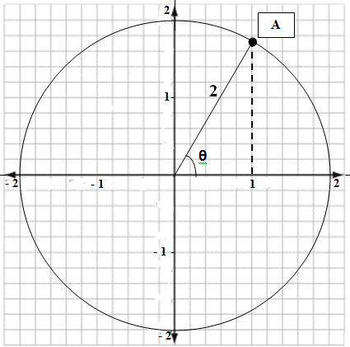
POINT S
principal $∠$
________
related acute$∠$
_____
POINT T
principal $∠$
________
related acute$∠$
_____
POINT C
principal $∠$
________
related acute$∠$
_____

- 2

PRACTICE:
HINT: Determine in which quadrants the given ratio could have the same sign.

Given angle$θ$ , where$0°≤θ≤360°$, determine two possible values of $θ$ where each ratio would be true. Sketch both principal angles.
a) $sinθ=0.4226$ b) $cosθ=-0.3420$

c) $cotθ=8.1516$ d) $cscθ=-2.3424$

e) $sinθ=0.4815$ f)$tanθ=-0.1623$

g) $cosθ=-0.8722$ h) $sinθ=-0.3154$

i) $cosθ=0.6951$

