1. The local ice cream shop keeps track of how much ice cream they sell versus the noon temperature on that day. Here are their figures for the last 12 days.
 | ICE CREAM SALES vs TEMPERATURE
Temperature ºC | 0 | 4 | 8 | 10 | 14 | 16 | 18 | 22 | 24
Ice Cream Sales ($) | 50 | 100 | 150 | 200 | 250 | 250 | 250 | 300 | 350

a) Draw a scatter plow of the data.

b) Draw the line of best fit.

c) Find the equation of the line of best fit in y = mx + b form.

d) Use the equation above to predict the ice cream sales for 35 degrees Celcius.

2.
- Correlation is positive when the values increase together
- Correlation is negative when one value decreases as the other increases.
- The closer to 1 or -1, the stronger the correlation. (ex. 0.85 is strong and 0.20 is weak)

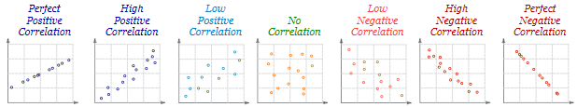
Classify each of the following scatter plots

3. The 14 students in Jaime’s math class measured their heights to the nearest centimetre.
150 | 168 | 157 | 170 | 158 | 147 | 154 | 169 | 143 | 172 | 166 | 155 | 165 | 157

- Determine the measures of central tendency and the range for this set of data.
MEAN | * (add all numbers) / how many
MEDIAN | * Rearrange the numbers in ascending order. If the set has even number of data, average the two numbers in the middle to find the median. If the set has odd number of data, then the median is the number in the middle.
MODE | * If one number repeated, mode 1; if two numbers repeated bimodal; if more than 3 numbers repeated multimodal.

b) Xavier is in the 40th percentile. How many students are shorter than Xavier? What is his height?

4. Find the quartiles of the data: 3, 7, 8, 5, 12, 14, 21, 13, 18

5. The following dollar amounts were the hourly collections from a Salvation Army kettle at a local store one day in December: $19, $26, $25, $37, $32, $28, $22, $23, $29, $34, $39, and $31.
Determine the quartiles for the amount collected.

