**Stretches, Compressions and Reflections of Quadratic Relations**

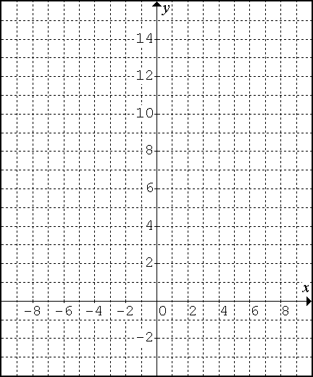

***(Warm-Up)* Task B: The Basic Parabola *y* = *x*2**

|  |  |  |
| --- | --- | --- |
| ***x*** | ***y* = *x*2** | **first differences** |
| -4 |  |
|  |
| -3 |  |
|  |
| -2 |  |
|  |
| -1 |  |
|  |
| 0 |  |
|  |
| 1 |  |
|  |
| 2 |  |
|  |
| 3 |  |
|  |
| 4 |  |
|  |
| *Recall: these are ↑*  *the ‘****step pattern****’.* |  |  |
|  |  |  |

1. Complete the table of values, including the first differences.
2. Graph the parabola.

**Task A: What happens when you graph *y* = *ax*2?**

* Change the slider for ***h*** and ***k*** to 0 and for ***a*** to 2. What equation does that produce? ______________

1. Describe the effect this had on the graph.

1. Complete the following information.

|  |  |  |  |  |  |  |  |  |  |  |  |  |  |  |  |  |  |  |  |  |  |  |  |  |  |  |
| --- | --- | --- | --- | --- | --- | --- | --- | --- | --- | --- | --- | --- | --- | --- | --- | --- | --- | --- | --- | --- | --- | --- | --- | --- | --- | --- |
|  | |  |  |  | | --- | --- | --- | | ***x*** | ***y* = 2*x*2** | **first differences** | | -3 |  | |  | | -2 |  | |  | | -1 |  | |  | | 0 |  | |  | | 1 |  | |  | | 2 |  | |  | | 3 |  | |  | | **vertex = ________________**  **axis of symmetry = _______**  **direction of opening = _____**  **step pattern =**  **____ ____ ____ ____** |

1. How does the value of ***a*** affect the step pattern?

* Back in **DESMOS**, change the slider for ***a*** to ½ (or 0.5). The equation: __________

1. Describe the effect this had on the graph.

1. Complete the following information.

|  |  |  |  |  |  |  |  |  |  |  |  |  |  |  |  |  |  |  |  |  |  |  |  |  |  |  |  |  |  |
| --- | --- | --- | --- | --- | --- | --- | --- | --- | --- | --- | --- | --- | --- | --- | --- | --- | --- | --- | --- | --- | --- | --- | --- | --- | --- | --- | --- | --- | --- |
|  | |  |  |  | | --- | --- | --- | | ***x*** | ***y* = ½*x*2** | **first differences** | | -3 |  | |  | | -2 |  | |  | | -1 |  | |  | | 0 |  | |  | | 1 |  | |  | | 2 |  | |  | | 3 |  | |  | |  |  |  | | **vertex = ________________**  **axis of symmetry = _______**  **direction of opening = _____**  **step pattern =**  **____ ____ ____ ____** |

1. How does the value of ***a*** affect the step pattern?

* Back in **DESMOS**, change the slider for ***a*** to -1. What equation does that produce? __________

1. Describe the effect this had on the graph.

1. Complete the following information.

|  |  |  |  |  |  |  |  |  |  |  |  |  |  |  |  |  |  |  |  |  |  |  |  |  |  |  |  |  |  |
| --- | --- | --- | --- | --- | --- | --- | --- | --- | --- | --- | --- | --- | --- | --- | --- | --- | --- | --- | --- | --- | --- | --- | --- | --- | --- | --- | --- | --- | --- |
|  | |  |  |  | | --- | --- | --- | | ***x*** | ***y* = -1*x*2** | **first differences** | | -3 |  | |  | | -2 |  | |  | | -1 |  | |  | | 0 |  | |  | | 1 |  | |  | | 2 |  | |  | | 3 |  | |  | |  |  |  | | **vertex = ________________**  **axis of symmetry = _______**  **direction of opening = _____**  **step pattern =**  **____ ____ ____ ____** |

1. How does the value of ***a*** affect the step pattern?

1. 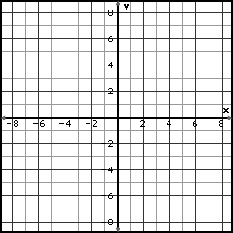If the equation was ***y* = -3*x*2**, what do you think the properties and graph would be? Try them in PENCIL!

**vertex = ________________**

**axis of symmetry = _______**

**direction of opening = _____**

**step pattern = ____ ____ ____ ____**

* Back in **DESMOS**, change the slider for ***a*** to -3 and confirm or adjust your answer above.

|  |
| --- |
| The graph of  produces a vertex = (____, ____)   * **vertical reflection** if ***a*** < 0 (e.g: ) axis of symmetry = ___________      * **vertical stretch** if |***a***| > 1 (e.g: ) step pattern = ___ ___ ___ ___ * **vertical compression** if |***a***| < 1 (e.g: ) direction of opening = ________________   Note: the | | signs around the ***a*** value are “absolute value” signs. It means to consider the numerical (number) value without considering the sign (positive or negative). |

**Task P: Practice!**

1. Graph each parabola.

|  |  |  |
| --- | --- | --- |
| a. | y = 3x2  Step Pattern: ____ ____ ____ ____ |  |
| b. | y = -2x2  Step Pattern: ____ ____ ____ ____ |  |
| c. | y = x2  Step Pattern: ____ ____ ____ ____ |  |
| d. | y = 4x2  Step Pattern: ____ ____ ____ ____ |  |
| e. | y = x2  Step Pattern: ____ ____ ____ ____ |  |
| f. | y = 5x2  Step Pattern: ____ ____ ____ ____ |  |
| g. | y = x2  Step Pattern: ____ ____ ____ ____ |  |