DIRECT vs. PARTIAL VARIATION

|  |  |  |
| --- | --- | --- |
| Example 1:  Stephen works at a hardware store and earns $9.25 for each hour he works. Let E represent his Earnings, and h represent the number of hours he works. | Example 2:  Popcorn pops, on average, at a rate of 4 kernels per second. Let P represent the amount of popcorn kernels popped, and s represent the number of seconds. | Example 3:  Branley works in sales and earns commission of 2% on the merchandise she sells. Define your variables and write an equation. |

These are the examples of ________ _______________. In example 1, E varies ___________ with the number

of hours. The graph of a direct variation relationship is a straight line through the ____________. The equation is in

the form ____________

|  |  |  |
| --- | --- | --- |
| Example 4:  Rio works at a local gym as a personal trainer. She earns $50 each shift and an additional $35 per hour of personal training. Let E represent her earnings, and h represent the number of p.t. hours. | Example 5:  Rhys’ bank account has $500. Each month he spends $50. Let B represent his balance, and let m represent the number of months that have passed. | Example 6:  Jessee repairs computer problems and charges a $50 service fee plus $30 per hour. Let F represent her total fee, and h represent the number of hours worked. |

These are the examples of ________ _______________. In example 5, B varies ___________ with the number

of months. The graph of a **partial** **variation** relationship is a straight line that ___________________________

The equation is in the form _____________

|  |  |  |
| --- | --- | --- |
| **Situation** | **Equation** | **D or P** |
| a) A cookie recipe makes 12 cookies for each egg in the recipe. |  |  |
| **b) An airplane was at an altitude of 1700m and is descending at 50m per minute.** |  |  |
| c) Danillo works as a tree planter for the government. He can plant 900 trees in a day. |  |  |
| **d) A cell phone plan is $20 per month but excludes text messaging. Each text message costs 20 cents.** |  |  |
| e) Meher cuts lawns in the summer and earns $15 for every lawn she cuts. |  |  |
| **f) A banquet hall charges $500 for the hall rental and $32.50 per person.** |  |  |

**DIRECT VARIATION**

**Example 1**

The new Mazda 3 Sport has gas mileage of 6 km per litre on highway. This can be modelled by the algebraic equation d=7.6n, where d represents the distance you can travel and n represents the number of litres you use.

Complete the table of values for the distance per number of litres and use your table to create a graphical model of this scenario.

|  |  |
| --- | --- |
| **n** | **d = 6n** |
| 0 |  |
| 1 |  |
| 2 |  |
| 3 |  |
| 4 |  |
| 5 |  |

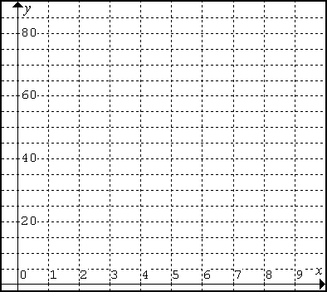

**Example 2**

Dooko Mobile Company does not charge any monthly fees, but charges $0.25 per minute of cell phone use. Model this scenario algebraically.

Create a table of values using your equation and create a graphical model.

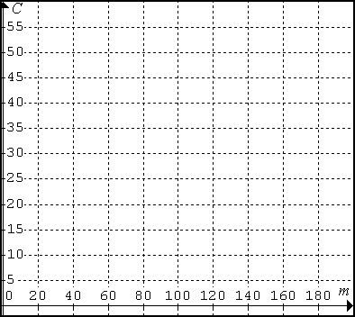

|  |  |
| --- | --- |
|  |  |
|  |  |
|  |  |
|  |  |
|  |  |
|  |  |
|  |  |

**PARTIAL VARIATION**

**http://www.kamsart.com/images/Travel/TAXI.WMFExample 1**

A taxi company charges a flat rate of $2.50 plus $0.35/km. The cost can be found using the equation _______________, where C represents the cost and k represents the number of kilometres.

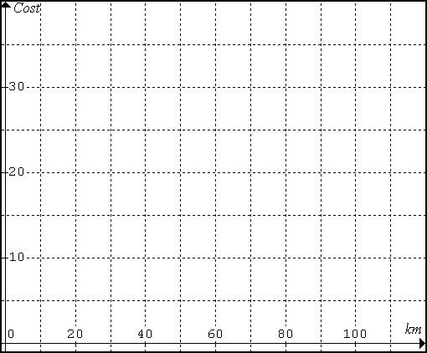Using the equation, complete a table of values. Using your table of values, create the graph.

|  |  |
| --- | --- |
| **k** | **C** |
| 0 |  |
| 20 |  |
| 40 |  |
| 60 |  |
| 80 |  |
| 100 |  |

**Example 2**

KeeDe Mobile Company charges $20 per month and an additional $0.25 per minute of long distance calls. Model this scenario algebraically.

Create a table of values using your equation and create a graphical model.



    
    
    
    
    
    
    
    
    