Name: ___________________________ MAP4C1 Date: ________________________

Geometry Review

Communication in all questions must include:
You will be given a reference sheet with conversions and formulas for area, perimeter, volume and surface area.
- Enough steps shown to clearly demonstrate thinking
- Solutions that are neat and easy to follow
- Proper use of mathematical symbols
- Equal signs aligned
- Units used as required
- Concluding statements for all word problems
- Fractions reduced to lowest terms
- Correct rounding.
Conversions:
- Convert each measurement as indicated:
  - 4.2 metres to feet and inches
  - 62 centimeters to metres and inches
  - 16 feet to metres and inches
  - Convert 4 litres to quarts and pints
  - Convert 10 pints to litres and quarts

- Which is more, 90 metres or 300 feet?

2D Geometry
- Find the area and perimeter of each shape:
- 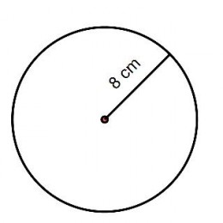

- 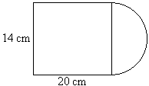

- 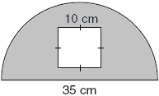

- 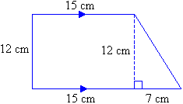

- 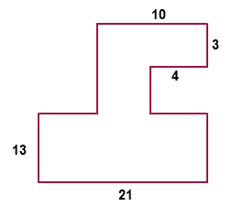

3D Geometry
- Find the surface area and volume of each figure
- 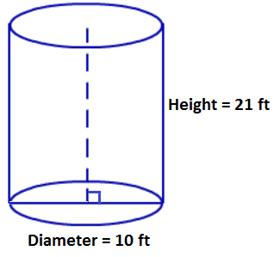

- 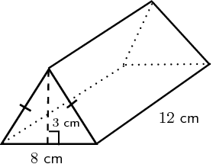

- 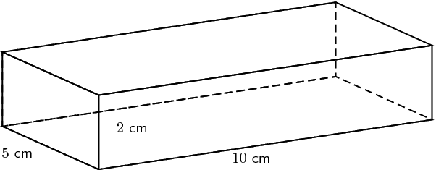
- 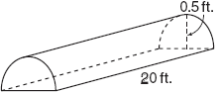

- 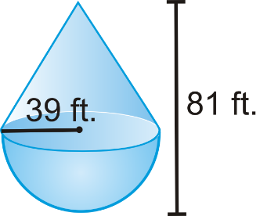

*Slant = 50 ft. long

Optimization
- The three rectangles shown all have the same perimeter. Which has the largest volume. Explain in words how you made your choice.

- A rectangular room needs to have an area of 60 m² . What are the dimensions of the room with a minimum perimeter, and what is the perimeter?

- You need to build a rectangular enclosure in your back-yard. You buy some prebuilt sections of fencing which are each 0.25m long. You buy a total of 40m of fencing. Determine the dimensions (length and width) which will maximize the area of your enclosure

- 35 m of rope are available to create a rectangular swimming area, using the beach as one side. What is the maximum area that can be produced?

- A marine biologist is collecting data. She has 100 m of rope with buoys to outline a rectangular or circular research area on the surface of the water. Which figure will enclose a greater area? Justify your answer by showing all calculations.

- A square-based prism must have a surface area of 96 cm² . What are the dimensions of the prism that produce the maximum volume, and what is the volume?

- A square-based prism has a volume of 50 in³ . Determine the minimum surface area.

