**Similar Triangles**



1. If AB is parallel to PQ,
   1. how do you know that ΔCAB ~ ΔCPQ?
   2. determine the length of x and y.

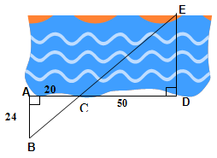

1. Leron is attempting to swim across a river. He needs to find out the distance across, so he draws the following scale diagram and determines the measurements on it. Using the diagram shown, determine how far it is across the river to the nearest metre.
2. Calculate the height of GI Joe’s roof.



1. Determine the value of x.



1. A 6 m ladder is leaning against a vertical wall with its foot 3.5 m away from the wall. Another ladder 7.5 m long is leaning against the wall, parallel to the first ladder. What distance is the foot of the second ladder from the wall?

**Trigonometric Ratios - *Sine, Cosine, and Tangent***

6. Label the hypotenuse (hyp), opposite (opp) and adjacent (adj) sides for marked angles.

D

|  |  |  |
| --- | --- | --- |
|  |  | F  E |

7. State the 3 primary trig ratios using the hint below

**SOH CAH TOA**

8. State the **three primary trig ratios** for the indicated angle in the following triangles.

|  |  |
| --- | --- |
| **sin βo=**  **cos βo=**  **tan βo=**  β | **sin βo=**  β  **cos βo=**  **tan βo=** |

**Solving for Unknown Angle Using Trig Ratios**

9. Find the indicated angle to the nearest degree.

|  |  |  |
| --- | --- | --- |
| x  8  5 | x  17  4 | x  5  13 |

10. Solve the following triangle. Round each side length to the nearest unit and angles to the nearest degree.

20

300

A

B

C

11. Captain Jack is navigating his ship to Port Harbour, which is directly north of the ship’s location. To compensate for an easterly current, he aims for a point on shore that is 5 km west of Port Harbour. Assuming that the point on shore is 20 km from his position now, at what bearing must Jack head his ship? **Bearing:** Clockwise angle from NORTH.

W

P

J

20 km

5 km

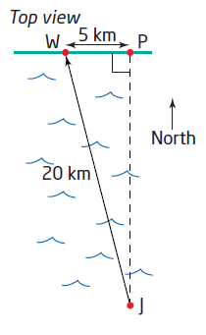

**Solving for Unknown Side Length Using Trig Ratios**

12. In ∆JKL find the length of x

300

J

K

L

10 m

x

13. In ∆ABC find the length of x

A

B

C

600

3.6 m

x

14. From a point on the ground 15 feet from the foot of a tree, the angle of elevation of the top of the tree is 21º.  Find to the nearest foot, the height of the tree.

