LEARNING GOAL: I will find the midpoint of a line segment

Part 1 – Investigation (draw the line on your notebooks)
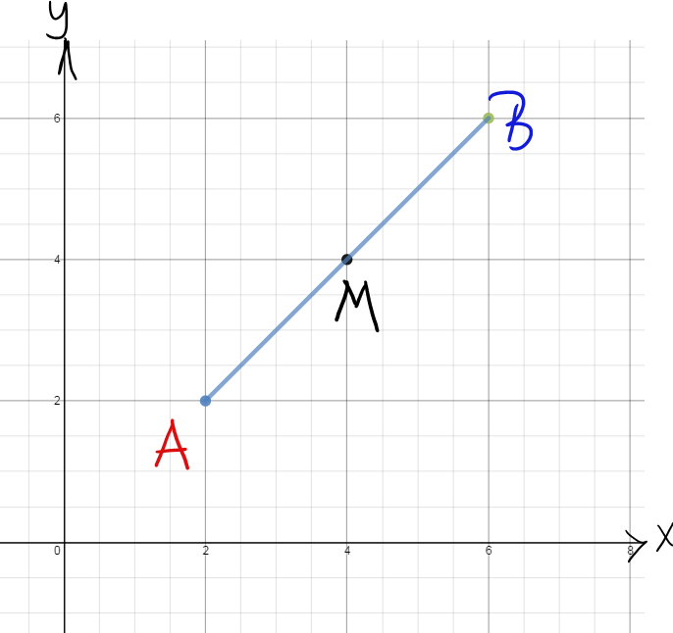

The midpoint of a line segment is the point that divides the length of the segment into 2 equal parts.
Ex 1: Find the midpoint of the line segment connecting A (1, 2) and B (5, 6).

Ex 2: Find the coordinates of the midpoint of the line segment connecting K (-6, 4) and L (4,-2) [-1, 1]

Ex 3: The midpoint of AB is M (-1, 7) for the point A (-5, 8) and B (x, y). Find x and y. (x = 3, y = 6)

Work on p. 55 # 5 – 8 and p.66 2ac, 3d, 5, 6, 13, 14, 23, and 29

