|  |
| --- |
| **Learning Goal:** I will find equations for medians and right bisectors.  **HW**: p.66# 8, 16, 17, and 19 |

**1) MEDIAN**

A median of a triangle **is a line segment that joins a vertex of a triangle to the midpoint of the opposite side.**

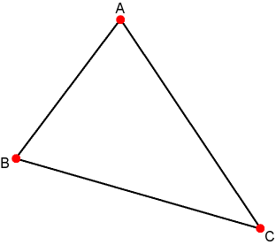**Sketch** the median of the triangle below from A to side BC. (Sketch it on the definition chart sheet)

|  |
| --- |
| **Step 1** Use a ruler to find the midpoint of the side.  **Step 2** Draw a segment from that midpoint to the opposite vertex.  **Step 3** Do this for all three sides and you'll find the **centroid** of the **triangle**! |

**2) RIGHT OR PERPENDICULAR BISECTOR**

A right bisector or a perpendicular bisector **is a line that is perpendicular to a line segment and divides the line segment into two equal parts.**

**Sketch** the perpendicular bisector of side BC in the triangle below.

|  |
| --- |
| **Step 1:** Use a ruler to find the midpoint of the side.  **Step 2:**  Set an edge of the set square on the given line so that the other edge is just in contact with the point. **Step 3:**  Draw a line that passes through the given point with the help of the set square. |

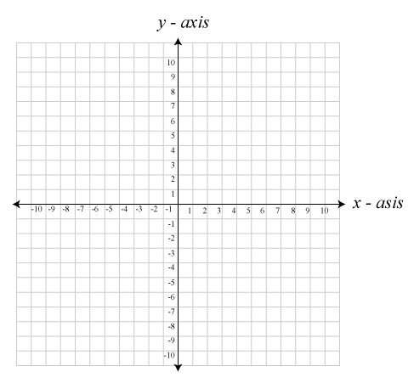**Ex 1:** Given triangle $ABC$ with vertices $A\left(-4,4\right)$, $B\left(2,-4\right)$ and $C\left(6,2\right):$

1. Plot the triangle on the grid below.
2. Find the equation of the median from vertex

M to side AB.

1. Draw the median.

|  |
| --- |
| Steps:   * 1. Find the midpoint   2. Find the slope between the midpoint and opposite vertex using   3. Use slope and a point on the line (either the midpoint or the vertex) to solve for b in   4. Determine the median equation by plugging in your m and b values into |

**Ex 2:** Given triangle $ABC$ with vertices $A\left(-7,-2\right)$, $B\left(-5,2\right)$ and $C\left(5,-3\right):$

1. Plot the triangle on the grid below.
2. Find the equation of the right bisector of AB.
3. Draw the perpendicular bisector of side AB on the grid given.

|  |
| --- |
| **Steps**   1. Find the midpoint 2. Find the slope between the same line (midpoint) using 3. Find the negative reciprocal slope (since the right bisector needs to intersect at 90o 4. Use negative reciprocal slope and midpoint to solve for b in 5. Determine the right bisector equation by plugging in your m and b values into |

An application of the equation of the right bisector: To find a point that is equidistant (_________________) from two towns to place a hospital, recreation centre or a fire hall.

|  |
| --- |
| **Work on p. 66 #8, 16, 17, and 19** |