Shortest Distance from a Point to a Line

- Given the point we can draw infinite different lines to the line but…
- The shortest distance is the line that hits it at a ⁰
- The shortest distance from a point to a line is the distance from the point to your line.

METHOD 1: Finding the Shortest Distance Graphically
Ex1. Find the shortest distance graphically between the point $(-4,-3)$ and the equation $y=-2x+4$.

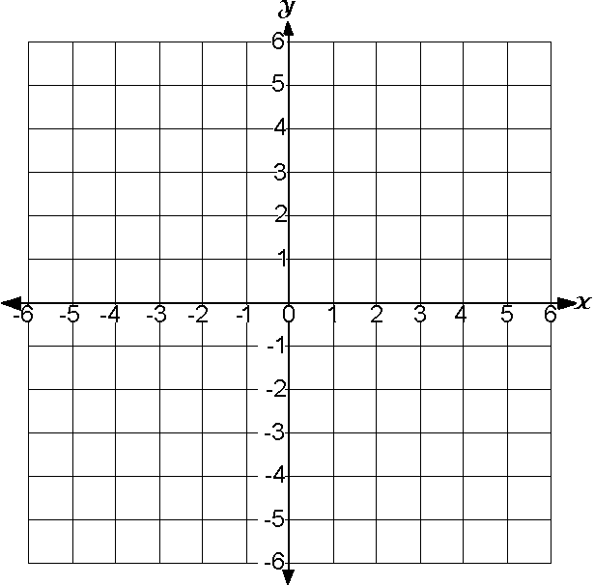

METHOD 2: Finding the Shortest Distance Algebraically
Ex2. Find the shortest distance from the point $C(4,-2)$ to the line passing through the points $A\left(1,3\right) and B\left(-4,-2\right).$
Step 1 Find equation of the line AB.
Step 2 Draw a line perpendicular to AB that goes through C. Let the point on AB be called D. Find the equation of the line CD.
Step 3 Find D, the POI of AB and CD (substitution or elimination).
Step 4 Find the length of CD.

Practice
Ex3. Determine the shortest distance graphically from $A(3,-1)$ to the line$2x-y+3=0$.

Ex4: Algebraically determine the shortest distance from the point $P(5,2)$ to the line passing through the points $R\left(-6 ,4\right) and S\left(-2, -4\right).$

Ex 5.Triangle $ABC$ has vertices$A(3,4)$, $B(-5,2),$ and $C\left(1,-4\right).$ Determine an equation for $AE$, the altitude from $A$to $BC$. What is the area of triangle$ABC$?
An altitude of a triangle is .

