Properties of Triangles
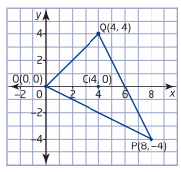
Ex1. a) Verify that C(4,0) is the centroid of OPQ triangle.
b) Verify that the centroid divides each median in a 2:1 ratio.

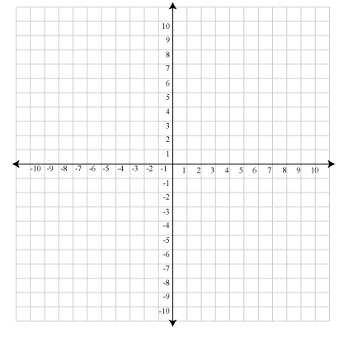
Ex2. The line segment joining the midpoints of two sides of a triangle is parallel to the third side and half its length. Verify algebraically this property in triangle A$(-10,1)$, R $(6,5)$ and T$(2,-11)$. Include a labelled diagram as part of your solution.

Ex3. A triangle has vertices M$(-7,-3)$, T$(6,10)$, and H $\left(3,-5\right).$
i) Verify that:
a. Triangle $∆MTH$ is a right triangle.
b. The median from the right angle to the hypotenuse is half as long as the hypotenuse.
ii) Calculate the perimeter.
iii) Calculate the area.

