|  |
| --- |
| [http://t1.gstatic.com/images?q=tbn:ANd9GcScy7LsBXdnU0ZXuyZawDGiuEWyk6-YmHd5yWV15gkzkDqVa77DyQ](http://www.google.ca/imgres?q=laptop+clip+art&hl=en&biw=1107&bih=617&gbv=2&tbm=isch&tbnid=NCV1SFw5DngSLM:&imgrefurl=http://www.computerclipart.com/computer_clipart_images/laptop_computer_coloring_page_0521-1004-3015-4009.html&docid=8PRvVSxIIGKSiM&w=300&h=270&ei=yjpDTorsDpDegQfRx-HGCQ&zoom=1)  Go to <http://bit.ly/trianglecentres> |

**Where is the center of a triangle?**

There are actually *thousands* of centers! Here are the 4 most popular ones:

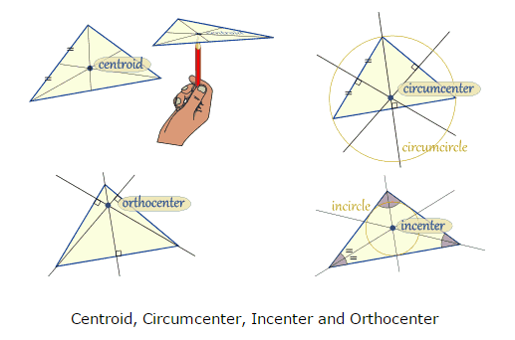

**1. CENTROID**

The **centroid** of a triangle is:

*

*

|  |
| --- |
| To determine the centroid **algebraically**:  1) Label vertices (or use letters provided)  2) find median of x and y coordinates: $(\frac{x_{1}+x_{2}+x_{3}}{3},\frac{y_{1}+y_{2}+y_{3}}{3})$ 3) This is the *centroid* (centre of mass) |

Diagram:

Linear10numbered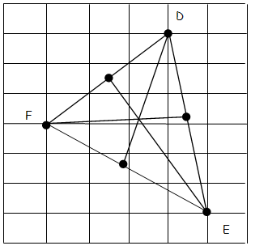

**Ex1.**Determine the centroid of the triangle with vertices

P(-6,9) Q(6,1) and R(-6,-7) **geometrically**.

**2. CIRCUMCENTRE**

The **circumcentre** of a triangle is

*

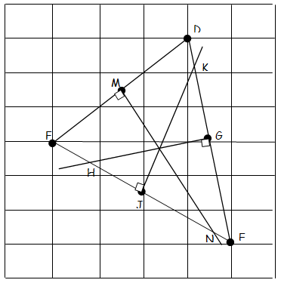Diagram:

|  |
| --- |
| To determine the circumcentre **algebraically**:  1) find equations of 3 right bisectors GH, JK and MN (find midpoints G, J and M, find slopes of DE, EF, and DF, find negative reciprocal for perpendicular slopes, use G, J, and M as points on the right bisectors)  2) find point of intersection of GH and JK (solve linear system using substitution)  3) this point is the *circumcentre*  4) confirm that this point is on the third right bisector MN (using LS = RS) |

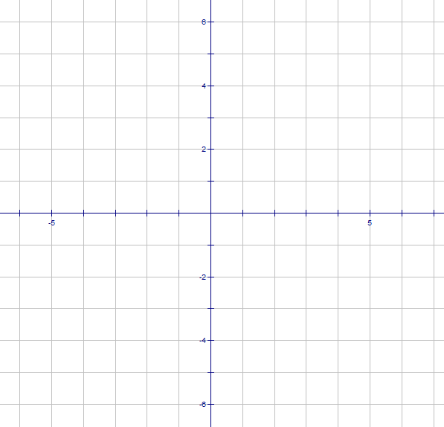**Ex2.** Determine the circumcentre of the triangle with vertices D(-1,3) E(3,-1) and F(-1,-5) **geometrically** and **algebraically** .

**3. ORTHOCENTRE**

The **orthocentre** of a triangle is

*

**Diagram**:

|  |
| --- |
| To determine the orthocentre **algebraically**:  1) find the equations of the 3 altitudes DN, FM, and EP (find slopes of EF, ED, & FD, and use negative reciprocals to find perpendicular slopes of DN, FM, and EP; use D, E, and F as points on the altitudes)  2) find point of intersection of DN and FM (solve linear system using substitution)  3) this point is the ***orthocentre***  4) confirm that this point is on the third altitude EP (using LS = RS) |

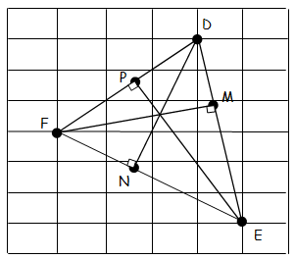

**Ex3.** Determine the orthocentre of the triangle with vertices A(-2,5), B(5,1) and C(-4, -5) **geometrically** and **algebraically**.

**SEATWORK** p.91 #28 and p.99 #24abc