**Lesson 1.1 Trigonometry Ratios in Right Triangles**

***Goal: Find the measure of sides and angles in right triangles using trigonometry ratios***

***RECALL***: 🡪 Right triangles have a _______________ angle

🡪The sum of all angles equal ___________

🡪Capital letters = ______________ Lower case letters = ______________

🡪 Angles are ACROSS from their corresponding ______________

🡪 If two sides are known use Pythagorean theorem (_______________) to find the third side

***Can only be used for RIGHT TRIANGLES***

**----------------------------**

***Put your calculator in DEGREE mode***

**Three Primary Trigonometric Ratios:**

**SOH CAH TOA**



$sin θ=______________________$

$cos θ=________________________$

$$tan θ=_______________________$$

Example 1:

1. State the 3 primary trig ratios for the following triangle
2. Find the trig ratios for the other acute angle. What is the measure of that angle?

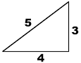

sin(37°)=

cos(37°)=

370

tan(37°)=

Example 2: Evaluate using your calculator. Round to 3 decimal places.

1. $\sin{30°}=$ b) $\cos{45°}=$ c) $\tan{60°}=$

Example 3: Solve for the unknown angle θ. Round your answers to 1 decimal place.

$sin θ=0.707$ c $os θ=0.139tan θ=\frac{6}{7}$

***Use 2nd or Shift on your calculator to access the INVERSE buttons***

***sin-1, cos-1, tan-1***

***Use***

Example 4: Find the length of side x. Example 5: Find the measure of angle A.

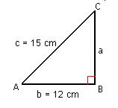



10

x

250

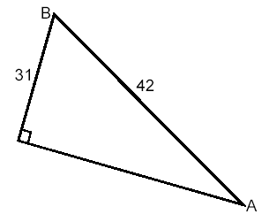Example 6: Solve the triangle (find the lengths of all sides and measures of all angles).

1. 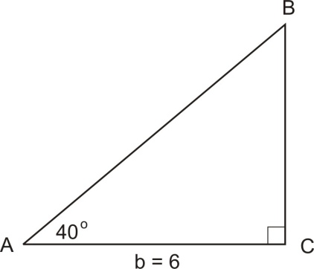 b)

Seatwork/Homework: p. 8 #3, 4, 5, 6