Part A – KNOWLEDGE & UNDERSTANDING

- Which of the following is a fixed expense? [1]
  - Dining out
  - Travelling overseas
  - Rent
  - Buying gifts

- Jordyn makes $80 per week from her part time job. How much is this per month? [1]
  - $173.33
  - $2080.00
  - $160.00
  - $320.00

- Which one of the following is not a type of accommodation? [1]
  - condominium
  - apartment
  - house
  - All of the above

- What is Liam’s down payment on a $500 000 house if he has a 5% down payment? [1]
  - $10 000
  - $5 000
  - $190 000
  - $25 000

- Mark moved into an apartment last year and pays $800/month. The landlord is raising the rent by 3% for the next year. By how much did the landlord increase Mark’s rent? [1]
  - $7
  - $24
  - $210
  - $30

- Convert 30 mm into cm: [1]
  - 200 cm
  - 0.2 cm
  - 3 cm
  - 20 cm

- Convert 5 feet into inches [1]
  - 2 inches
  - 60 inches
  - 24 inches
  - 0.2 inches

- All of the following are ways to pay less interest on your mortgage except: [1]
  - making extra payments on your mortgage
  - putting an extra lump sum down on your mortgage
  - paying your regular payments
  - skipping your payments

- A person who owns an apartment building is: [1]
  - the landlord
  - the tenant
  - the co-signer
  - the superintendent

- Which of the following is an advantage for renting when compared to buying? [1]
  - responsible for paying property tax
  - no maintenance required by you
  - an investment

- Determine the following probabilities: [2]

  - The probability of rolling a 5 with a regular die. ________________

  - The probability of drawing a 7 from a standard deck of cards. _______________

- Determine Jacob’s annual gross income if he works 30 hours a week for 50 weeks at a rate of $11.40 per hour. [2]

- Frankie works part time in a fast-food restaurant and has a net earnings of $450/week. He lives with his mom and step-dad. His average weekly expenses are:

Family Contribution $150.00
Lunches $50.00
Entertainment $40.00
Music Downloads $10.00
Magazines $5.00
Frankie saves the rest of his earnings in a savings account.

- How much is he able to save weekly? [2]

- What percent of his earnings is he saving? [2]

14) Rental amounts should not exceed 25% of the monthly gross earnings. Calculate the maximum monthly rental amounts for each of the following earnings:

- $11.25 per hour for a 40-hour work week. [2]

- $42 000 per year. [2]

- $2500 per month. [1]

Part B – APPLICATION

- A landlord (Bilbo Baggins) can collect a deposit from a new tenant. The deposit cannot be more than one month’s rent. This deposit cannot be used for cleaning or repairs to the rental. If you rent an apartment for $150/week:

- What is the most you might pay as a deposit? [1]

- Write the cheque to the landlord for one month’s deposit. [3]
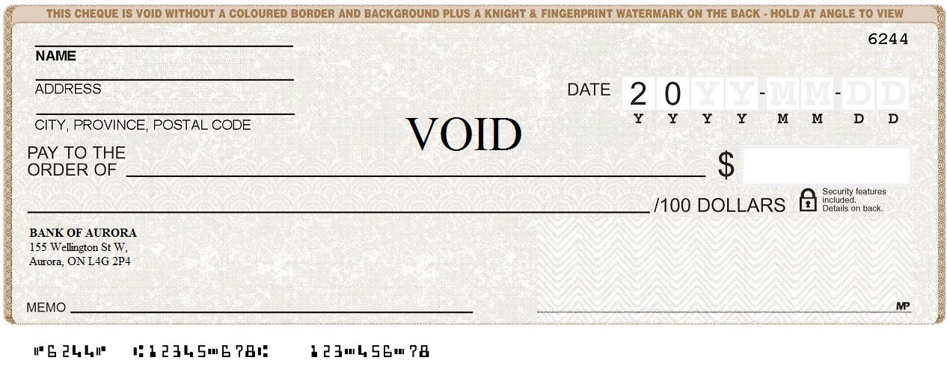

- If the next year your rent increases by 5%, how much will you pay per month? [2]

- Ethan has decided to create a budget for the month of December. He makes $11.50 per hour and estimates he will work for 40 hours during the month of December. He figures Christmas presents will cost him $250. He would like to put at least $100 of his income into savings. He takes public transportation which will cost him $50 for the month. He knows that he will be going out over the holidays and must set aside some money for entertainment and food.

  - What will be his gross income for the month? [1]

  - Complete the budget table below. Include the expenses provided and then complete the budget for him. [4]

Budget for December
Entertainment
Transportation
Clothing
Gifts
Food
Savings
Other

Part C – THINKING
- In basketball, Sean got a basket 110 times out of 150 free throws. Zack got a basket 90 times out of 120 free throws.
  - Calculate the probability of three decimal places of getting a basket on the next throw for: [2]
Sean __________________ Zack __________________

  - Which of the two players is more likely to get a basket on the next free throw? [1]
__________________
2) A department store offers “scratch and win” tickets to its customers. The store claims that 20% of the tickets result in customers getting a discount.
a) What is the probability of getting a winning ticket as a fraction? [1]

b) If the store prints 1000 tickets, how many winning tickets are there? [1]

3) The following table shows Moniaca’s income and expenses for one month: [3]

Income | January
Net Pay | $2500
Other Income | $500.00
Total Income
Expenses | January
Rent | $850.00
Utilities | $150.10
Food | $350.00
Transportation | $80.00
Car Insurance | $150.00
Clothing | $200.00
Savings | $250.00
Other (miscellaneous) | $222.00
Total expenses
Balance + / –

4) Complete the table. Is she over or under budget? By how much? [2]
- If Theresa comes under budget, she balances her savings for the month by contributing 60% of it to savings and 40% of it to clothing. If she comes over budget, she balances it by reducing the miscellaneous spending.
How does she balance her budget this January? [1]
5) You purchase a $600,000 house by making a 10% down payment.

- What will the mortgage amount be after the down payment? [2]

- A guideline suggests that homeowners set aside about 2% of the house purchase price each year for maintenance and repairs. What amount will you need each year for this home’s maintenance and repairs? [1]

Part D – COMMUNICATION
- State 2 advantages of saving money. [2]

- State four costs (other than rent) that might be associated with owning accommodations. [4]

____________________________

____________________________

____________________________

____________________________

3) Give one advantage and one disadvantage of filing your income tax return with an accountant.
Advantage | Disadvantage

4) What is the difference between theoretical probability and experimental probability? Use an example in your explanation. (2p)

5) Name four life changes that can affect a budget. (4p)

-
-
-
-

