PART A - KNOWLEDGE & UNDERSTANDING
1. Evaluate the following expression using the rule of BEDMAS. Show at least one middle step.
3 x (10 - 4÷2) = | 2 x (5 + 3 x 3) =

2. Evaluate the following expression by finding the lowest common denominator.
$\frac{2}{3}+\frac{1}{6}-\frac{4}{9}=$ | $\frac{1}{5}+\frac{3}{10}-\frac{7}{20}=$

3. Convert the following mixed number into improper fraction.
$$2\frac{3}{4}=$$ | $$1\frac{2}{3}=$$

4. Evaluate the following expressions and REDUCE your final answer to lowest fraction: [2 marks each]
a. $\frac{3}{4}×\frac{8}{9}=$ | b. $\frac{6}{7}÷\frac{3}{14}=$

5. Round the following to the desired place:

a) 10.222 to the nearest tenth (one decimal place) | b) 10.296 to the nearest hundredth (two decimal places)

6. Fill out the following table:
FRACTION | DECIMAL | PERCENT
$$\frac{1}{8}$$
 | 0.40
 |  | 75%

7. Convert the following quantities to the desired units.

a) 3 grams to milligram | b) 12 decigrams to kilogram | c) 2.2 millimetres to meters
d) 4.2 kilometers to decameters | e) 5 liters to milliliters | f) 3.4 liters to centiliters

8. State the following in scientific notation.
a) 36000000 | b) 0.00000036

9. Convert the following quantities to the desired unit. Round the answer to the nearest hundredth [1 mark each]
a) 16.5 inches to centimeters | b) 10 ¾ yards to meters | c) 4 feet to yards
d) 3 US liquid pint to milliliters | e) 5 cubic meter to cubic yards | f) 4 (statute) miles to kilometers

10. Evaluate the following:
a. 3′ 9′′ + 2′11′′ | b. 6′ 9′′ - 3′ 10′′

11. Write a statement for the following formula using full sentences.

$PF=\frac{R_{t}}{Z}$ where PF = power factor of an AC circuit
R_{t} = total circuit resistance
Z = circuit impedance
_______________________________________________________________________________________________

_______________________________________________________________________________________________

12. $b^{2}=c^{2}-a^{2}$, solve (isolate) for c.

PART B – APPLICATION
Show your work for full marks and include a therefore statement using a full sentence for communication marks.
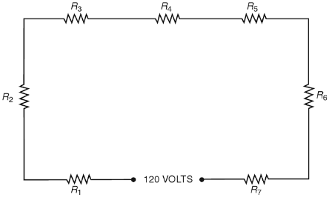
1. If 14 7/9 watts are distributed equally over each of the resistors shown in this figure, find the average number of watts per resistor.

2. A total load of 10,620 watts is distributed equally over the 5 branch circuits shown. What is the average load per circuit in watts?
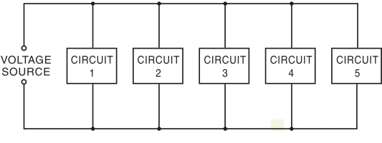
3. What is the shortest length of ½ - inch conduit from which the following pieces can be cut: 4 5/8 inch, 3 ½ inch, 5 ¾ inch, 6 1/8 inch and 3/8 inch? Allow 1/16 inch for saw cuts.

4. An electrical contractor employs 10 people. Five people earn $25 per hour, two people earn $20 per hour and the remaining people earn $18 per hour. What is the total hourly wage earned by all 10 people?

5. The actual inside diameter (I.D) of a 3-inch conduit is 1.567 inches and the actual outside diameter (O.D) is 3.459 inches. What is the wall thickness (W.T) of this conduit?
W.T
I.D
O.D
W.T

6. What is the ratio of the speed of generator A with an output of 8500 watts to generator B with an output of 1500 watts? Express your answer in lowest terms.

7. In replacing 40 lamp bulbs, an apprentice breaks 8. Find the percent broken.

8. The marked value of a capacitator is 470 nanowatts. Write this value in watts using scientific notation.

9. A rectangular concrete pad 200 inches wide and 400 inches long supports four transformers. Each transformer base measures 30 inches by 25 inches. What percent of the pad surface area is covered by the transformers? Round the answer to the nearest hundredth percent.
Transformer
Transformer
Transformer
Transformer
AREA = Length x Width

10. Find the total resistance (R_{t}) of the three field rheostats shown. Express the answer to the nearer hundredth.
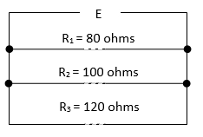
$$\frac{1}{R_{t}}=\frac{1}{R_{1}}+\frac{1}{R_{2}}+\frac{1}{R_{3}}$$

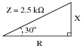
11. A series AC circuit exhibits a total impedance of 1.6 kΩ, with a phase shift of 30 degrees between voltage and current. Use the appropriate trigonometric ratio to calculate the equivalent values of R and X in this series circuit.
Z = 1.6 kΩ

