Name: ___________________________ MAP4C1 Date: ________________________

Trigonometry Review
You will be given the following information:

a² + b² = c² SOH CAH TOA

$\frac{a}{\sin{A}}=\frac{b}{\sin{B}}=\frac{c}{\sin{C}}$ $\frac{\sin{A}}{a}=\frac{\sin{B}}{b}=\frac{\sin{C}}{c}$

$a^{2}=b^{2}+c^{2}-2bc\cos{A}$ $\cos{A}=\frac{b^{2}+c^{2}-a^{2}}{2bc}$

Communication in all questions must include:
- Enough steps shown to clearly demonstrate thinking
- Solutions that are neat and easy to follow
- Proper use of mathematical symbols
- Equal signs aligned
- Units used as required
- Concluding statements for all word problems
- Fractions reduced to lowest terms
- Correct rounding.
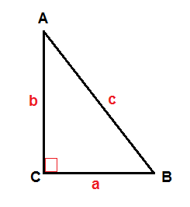
- Write the three trigonometric ratios for A in the following triangle:

Sin A = Cos A = Tan A =

- For each triangle below:
- Explain which strategy/equation you would use to find the missing side (x).
- Find the missing side (x) in each diagram. (Include units and round to 1dp)

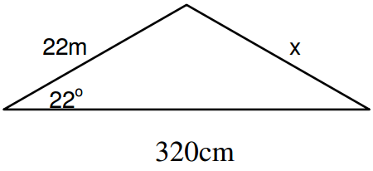
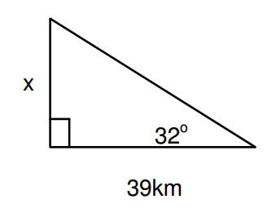
a) b)

- For each triangle below:
- Explain which strategy/equation you would use to find the missing angle (ϑ)
- Find the missing angle (ϑ) in the diagram below. (Include units and round to 1dp)

- b)
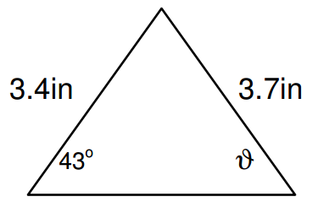
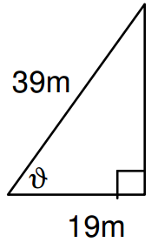

- a) What does it mean to “solve a triangle”?

- Solve the triangle. Summarize your answers in the chart. (Round to 1 dp)

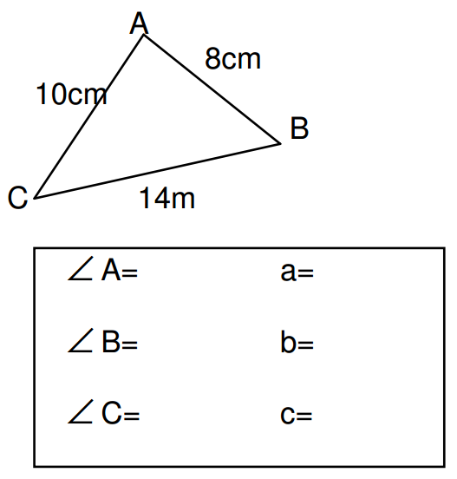

- Angle A is between 0ᴼ and 180ᴼ. Determine all measures of angle A in each of the following cases:

a)sin A = 0.2079 b) cos A = -0.8191 c) tan A = 1.428 c) tan A = -2.145

Communication:

- How do you know when to use SOH CAH TOA? How do you know when to use the Sine Law? How do you know when to use the Cosine Law? Describe in words and given an example.

Word Problems (answer on a separate piece of paper):
Draw and label a diagram for each. Round to 1 dp. Remember to write a “therefore” statement at the end.

- A ladder 10 feet long is leaning against a wall at a 71ᴼ angle. How far from the wall is the foot of the ladder? How high up the wall does the ladder reach?

- Billy was making a blueprint of his home, which is triangular in shape. One side of the triangular blueprint is 1.3 meters long. The angles in the triangle at each end of the 1.3m side are 44ᴼ and 101ᴼ. Determine the lengths of the other two sides of the blueprint.

- A machinist is cutting out a large triangular piece of metal to make a part for a crane. The sides of the piece measure 58 inches, 46 inches, and 62 inches. What are the angles between the sides?

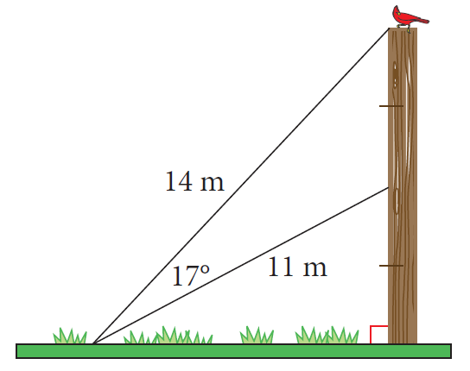
- A pole is supported by two guy wires, asshown. One wire is attached to the top ofthe pole and the other is attached at themidpoint.
- Determine the height of the pole.
- How far from the base of the poleare the wires anchored?

More practice: Complete Obtuse Angle Worksheet and Textbook questions: p. 54 # 1, 2, 4, 6-27

Trigonometry Flow Chart:
The angles in any triangle add to 180ᴼ

