1. Given the following points: Y(6, -1) and O(-3, 5), find:

|  |  |
| --- | --- |
| a. Length of YO | b. Midpoint of YO |
| c. Slope of YO | d. Equation of the line YO |

1. Given the circle , state its center and radius: _______________ _______________
2. The point (6,-3) is on a circle that has its centre at (0, 0). Find the equation of the circle.
3. If the midpoint of a line segment is at M(-2, -1) and one endpoint is at A(1, 4). Find the coordinates of the other endpoint, P.
4. 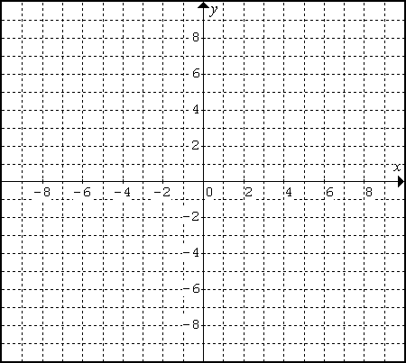A quadrilateral has vertices S(-2, 5), T(5,2), O(4,-4), & P(-3,-1). Use all applicable skills from this unit to determine what type of quadrilateral “STOP” is – be as specific as possible. Show ALL your calculations.

*What’s your plan? IE: What do you need to calculate?*

1. A triangle has vertices with coordinates R(4, -4), A(-5, -4) and T(1, 2). Find the equation of the median from R to the midpoint of side TA.

*What’s your plan? IE: What do you need to calculate?*

1. A right triangle has vertices C(-2, 2), T(0, 6), W(4,4). Verify that the midpoint of the hypotenuse is equidistant from all three vertices.

*What’s your plan? IE: What do you need to calculate?*



1. ΔMAN has with vertices at M(-3, 5), A(-6, -7), N(4, -1). Determine the length of the median from M to AN.

*What’s your plan? IE: What do you need to calculate?*

1. **Line segments IN and ON are equidistant. Determine the values of a if I(-6, -4), N(-2, -1), and O(1, a).



1. Line segment HI has H(3, -1). The length of HI is . What could the coordinates of I be?



1. ΔPET is isosceles with vertices at P(4, -1), E(-1, 0), T(3, -6). The two equal sides are PE and PT. Verify that the median from P to ET is also an altitude.

*What’s your plan? IE: What do you need to calculate?*

1. A circle with the equation x2 + y2 = 25 has its centre at (0, 0). A chord of the circle has its end points at M(-2, 6) and E(-6, -2). Determine the equation of the perpendicular bisector of ME and verify that the perpendicular bisector passes through the centre of the circle.

*What’s your plan? IE: What do you need to calculate?*

Answers:

1a. =10.8 b. (1.5, 2) c.  d.  or  2. (0, 0); 4 3.  4. (-5, -6)

5. opposite sides: 7.6 and 6.1; opposite slopes:  and ; parallelogram 6.  or  7. all distances are  8.  = 9.2 9. a is -5 or 3 10. (1, 5); (5, 5); (9, 1); (9, -3); (5, -7); (1, -7); (-3, -3); or (-3, 1)

11. the slope of the median is  and the slope of ET is  so they’re opposite reciprocals 12. 