Your task is to locate or photograph an image of a real life parabola and then determine its equation. Try a web search using Google images, but be more specific than simply “parabola”. Make sure you choose or take a clear image that fills at least half of a page.
Part A (APPLICATION 10)
Once you find or take an image, you need to draw grids on it using a web tool or traditionally using a pencil and a ruler. If you choose to use technology, the website at this link “http://sporkforge.com/imaging/grid.php” is quite user-friendly. Just choose a file from your device and upload it. When you finish adding a grid to your image download it to your computer. Now it is up to you where you want the vertex to be; however, make sure:
a) Your grids are spaced approximately 1 cm.
b) The vertex of the arch does not fall on the y-axis. (That would be too easy, no?)
c) There are two x-intercepts.

Fully label the key points of your graph including axes, the vertex, y-intercept and zeros, as well as any other points you use in Part B. 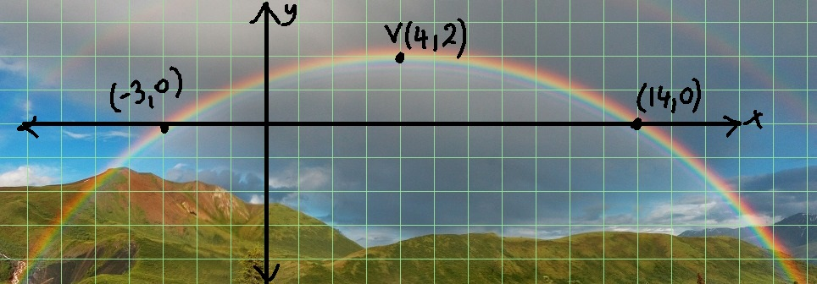
(-3, 0)
(4, 2)
(11, 0)
Part B (KNOWLEDGE 10)
1. Determine the equation of the parabola in vertex form using the vertex and another point on the graph that is not one of the x-intercepts.
2. Rewrite the equation from vertex form in step #1 into standard form, and use your answer to state the y-intercept.
Part C (KNOWLEDGE 10)
3. Now starting again from the beginning (not from step #2), use the x-intercepts from the graph and another point on the graph that is not the vertex to write the equation of the parabola in factored form.
4. Rewrite the equation from factored form in step #3 into standard form and state the y-intercept.
Part D (THINKING 5)
5. Compare your answers from #2 and #4 in part B. Are they the same or different? How are they different? How are they the same? Explain in detail any differences and give reasons why they might be different.
Part E (COMMUNICATION 4)
 | Level Four | Level Three | Level Two | Level One
Expression and organization of ideas and mathematical thinking | Expresses and organizes mathematical thinking with a high degree of effectiveness | Expresses and organizes mathematical thinking with considerable effectiveness | Expresses and organizes mathematical thinking with some effectiveness | Expresses and organizes mathematical thinking with limited effectiveness
Use of conventions, vocabulary, and terminology | Uses conventions, vocabulary and terminology with a high degree of effectiveness | Uses conventions, vocabulary and terminology with considerable effectiveness | Uses conventions, vocabulary and terminology with some effectiveness | Uses conventions, vocabulary and terminology with limited effectiveness

